Jacqueline Ludorf 505 Park Avenue
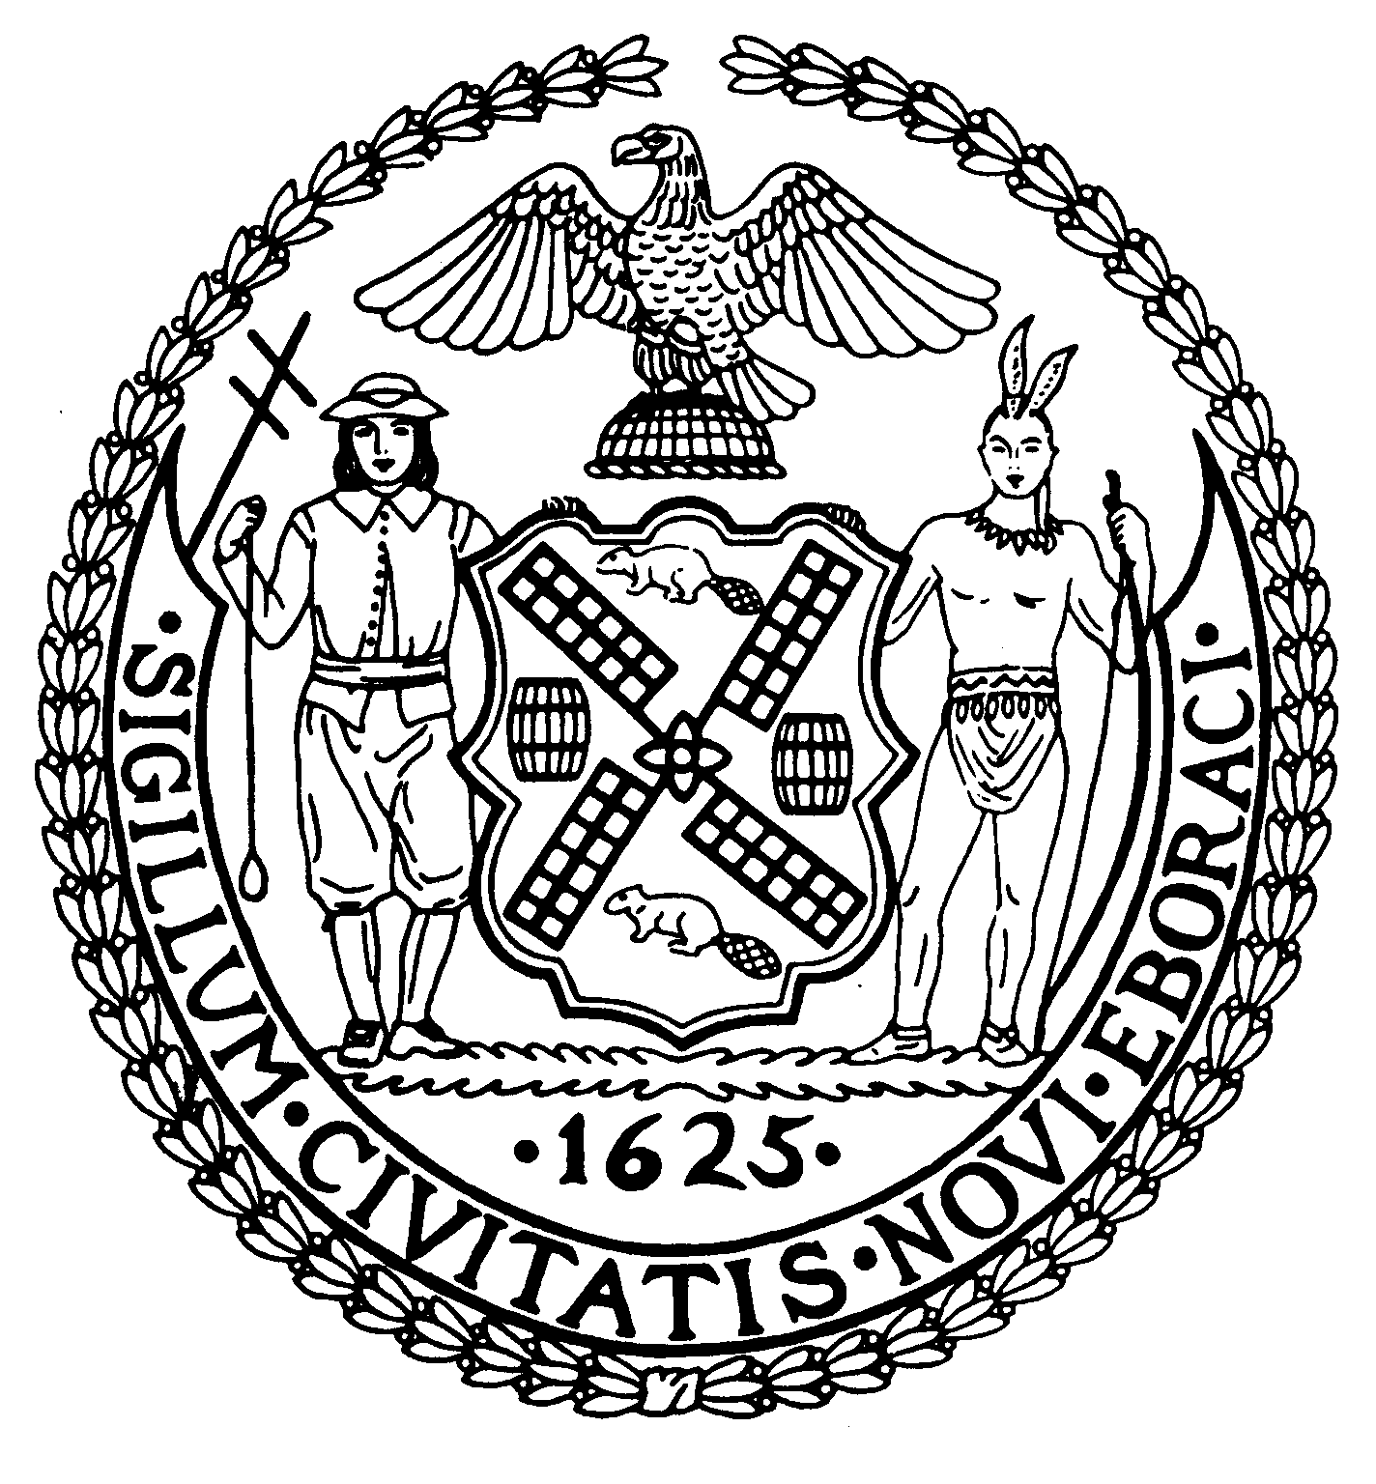
Chair Suite 620
New York, N.Y. 10022

Latha Thompson (212) 758-4340
District Manager (212) 758-4616 (Fax)
www.cb8m.com Website
info@cb8m.com - E-Mail

The City of New York

Manhattan Community Board 8

Youth and Education Committee Meeting

The Blood Center
310 East 67th Street, Conference Room
January 25, 2010
7:00 pm

Agenda

- Report CECD2 on Re-zoning Issue

- Open DOE items from prior meetings

- Report on Progress of Second Teacher in the classroom

- Future months’ Agendas

- New Business/Old Business

James Clynes and Judith E. Schneider Co-Chairs

