Jacqueline Ludorf 505 Park Avenue
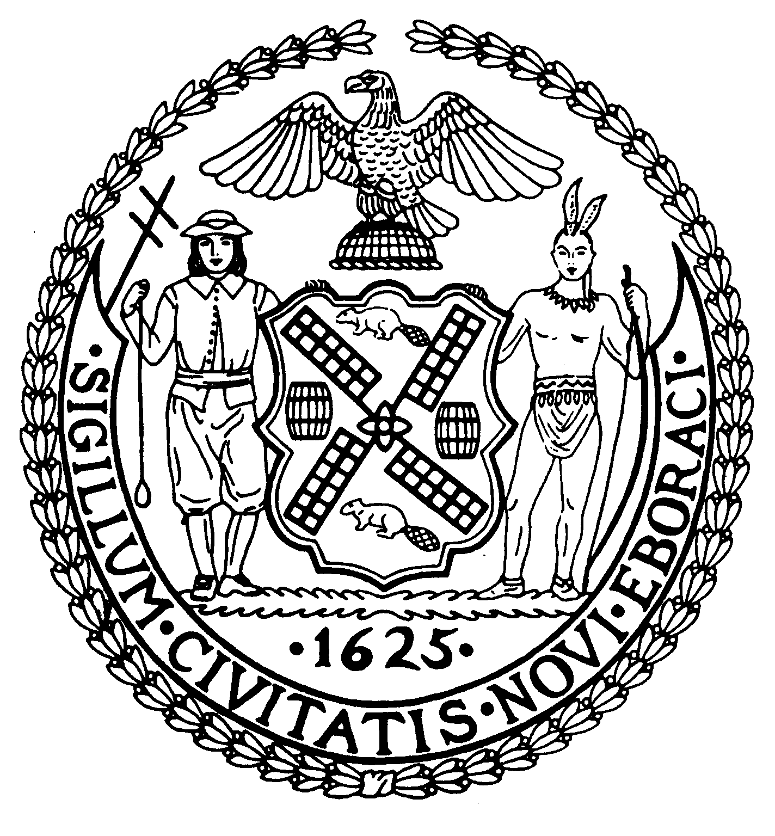
Chair Suite 620
New York, N.Y. 10022

Latha Thompson (212) 758-4340
District Manager (212) 758-4616 (Fax)
info@cb8m.com- E-Mail
www.cb8m.com – Website

The City of New York
Manhattan Community Board 8

Environment and Sanitation Committee Meeting
Monday, January 31, 2011
Hunter College School of Social Work
129 E. 79th St, Room #1010
6:30 pm

Board Members Present: Dave Kleckner, Debbie Teitelbaum, Mary Pike, Judy Schneider, Barry Schneider, Teri Slater, Ellen Polivy

Committee Members Absent: Roy Carlin, Jonathan Horn, Michael Auerbach

Number of Attendees: 10

The meeting was called to order at 6:35pm

1. Third Harbor Water Tunnel Shaft 33-B Water Main Update by NYC Department of Environmental Protection (DEP) and NYC Department of Design & Construction (DDC)

DEP Assistant Commissioner Mark Lanaghan and DDC Assistant Commissioner Thomas Foley provided an update on the Third Harbor Water Tunnel Shaft 33-B and water mains (project time frame Summer 2010 – Summer 2013).

- Contract has been in place for several months with Halcyon Construction to install utility infrastructure in conjunction with Con Edison.
- They’re making room for the trunk main that will connect to the tunnel between 3rd Avenue and 1st Avenue along 59th Street.
- 44” steel main pipe is being constructed to be made ready for installation
- Construction of 20” distribution main is proceeding
- In response to some noise complaints in neighboring CB6, weekly meetings have been convened with Halycon Construction contractor, noise mitigation plans have been revised, noise barriers installed, jack hammers provided with mufflers, work schedule has been altered to conduct the noisiest work early during the evening, etc.
- Steel plates are installed to cover work during the daytime, which generates some negative attention, but they are backfilling as quickly as possible to minimize use of plates.
- Re: the local distribution main at First Avenue, gas utility work has been completed and electrical utility work is underway.
- DDC Community Construction Liaison is Sarah Wilmoth of consulting firm Ammann & Whitney, who is charged with keeping stakeholders informed, identifying and resolving issues, and providing regular updates and advisories. She can be reached at 212-223-6190 and at east59thccl@gmail.com.
- The location of the secondary (i.e., redundant or back-up) water main has not yet been selected as review, analysis and discussion between DDC and DEP is still on-going. CB8 will be promptly informed of the decision.

2. Gas Drilling in the Delaware River Basin.

The Delaware River Basin Commission (DRBC), representing Delaware, New Jersey, Pennsylvania, and New York, issued draft natural gas development regulations for the Delaware River Watershed on December 9, 2010 prior to NYS Governor Andrew Cuomo – one of the five current DRBC Members – assuming his office on January 1, 2011.

The CB8 Environmental & Sanitation Committee discussed concerns that DRBC has been proceeding without seeking input and feedback here in New York City via public hearings, which are being conducted elsewhere.

DRBC also should consider that the U.S. Environmental Protection Agency is studying hydraulic fracturing, the stimulation process that is used to access shale gas. EPA’s study is examining the potential impacts on drinking water, public health and the environment and is due to be issued in 2012. Further, New York State is re-examining its high volume hydraulic fracturing environmental study and has a ban in place through July 1, 2011.

Therefore, the Chair of Manhattan CB8 is sending a letter provided by the Environment & Sanitation Committee (attached) to the DRBC’s Executive Director, copying our federal, state and local elected officials, noting concern that NYC has not been included in the public hearings given that our drinking water will be directly affected by any decisions that are made by the DRBC.

Meeting adjourned at ~7:15 pm.

Respectfully submitted,
Dave Kleckner and Debbie Teitelbaum
Co-chairs Environment and Sanitation Committee

