Jacqueline Ludorf 505 Park Avenue
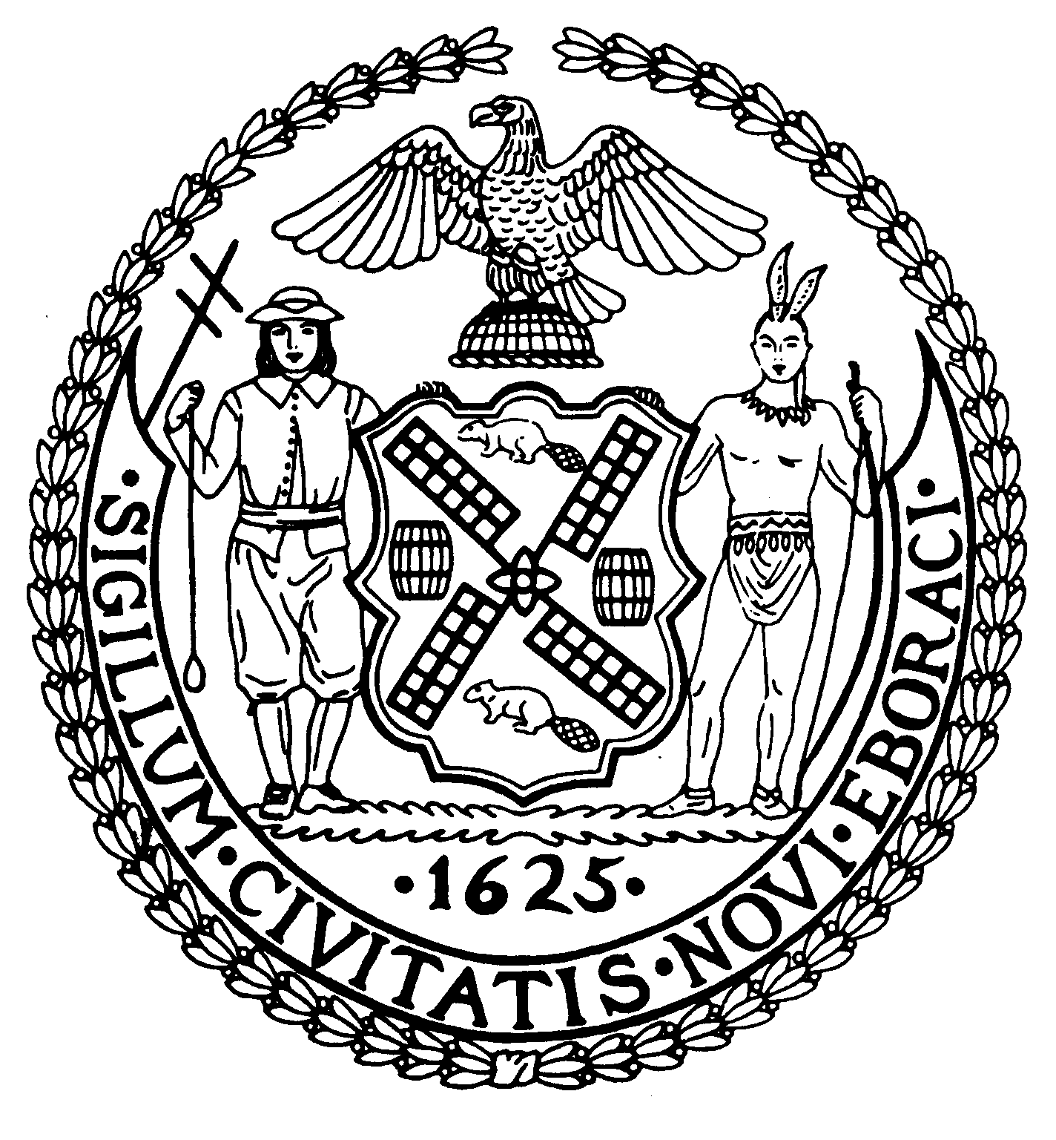
Chairman Suite 620
New York, N.Y. 10022

Latha Thompson (212) 758-4340
District Manager (212) 758-4616 (Fax)
www.cb8m.com Website
info@cb8m.com - E-Mail

The City of New York
Manhattan Community Board 8

Second Avenue Task Force Committee
Wednesday, January 26, 2011
New York Blood Center
310 East 67th Street
Auditorium
6:30PM

Agenda

1. Construction Update - including information on the street impacts of Second Avenue Subway construction.

2. Site improvements

3. Results of community input on color and privacy screens for ancillary facilities

4. Old Business

5. New Business

M. Barry Schneider and H. Patrick Stewart, Co-Chairs

