Jacqueline Ludorf 505 Park Avenue, Suite
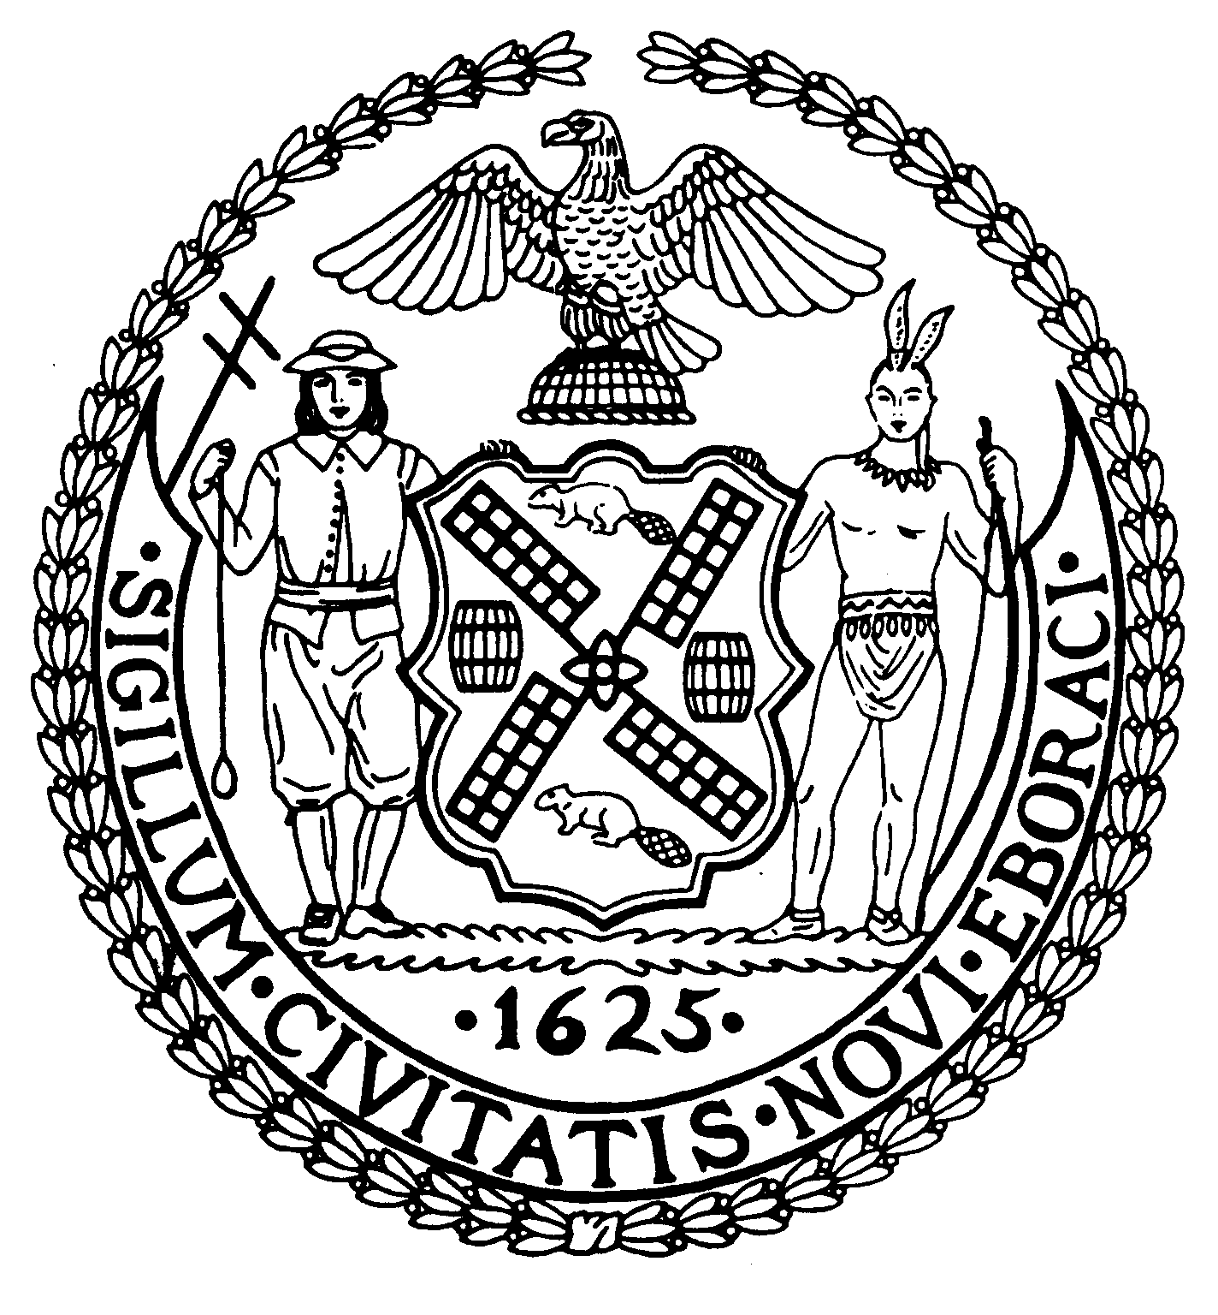

Chair New York, N.Y. 10022-1106

(212) 758-4340
Latha Thompson (212) 758-4616 (Fax)
District Manager www.cb8m.com - Website
info@cb8m.com - E-Mail

The City of New York
Manhattan Community Board 8

Environment and Sanitation Committee

Monday, January 31, 2011

6:30PM

Agenda

- Third Harbor Water Tunnel Shaft 33-B Water Main Update by NYC Department of Environmental Protection and NYC Department of Design & Construction."

- Old Business

- New Business

David Kleckner and Debra Teitelbaum, Co-Chairs

