Jacqueline Ludorf 505 Park Avenue, Suite 620
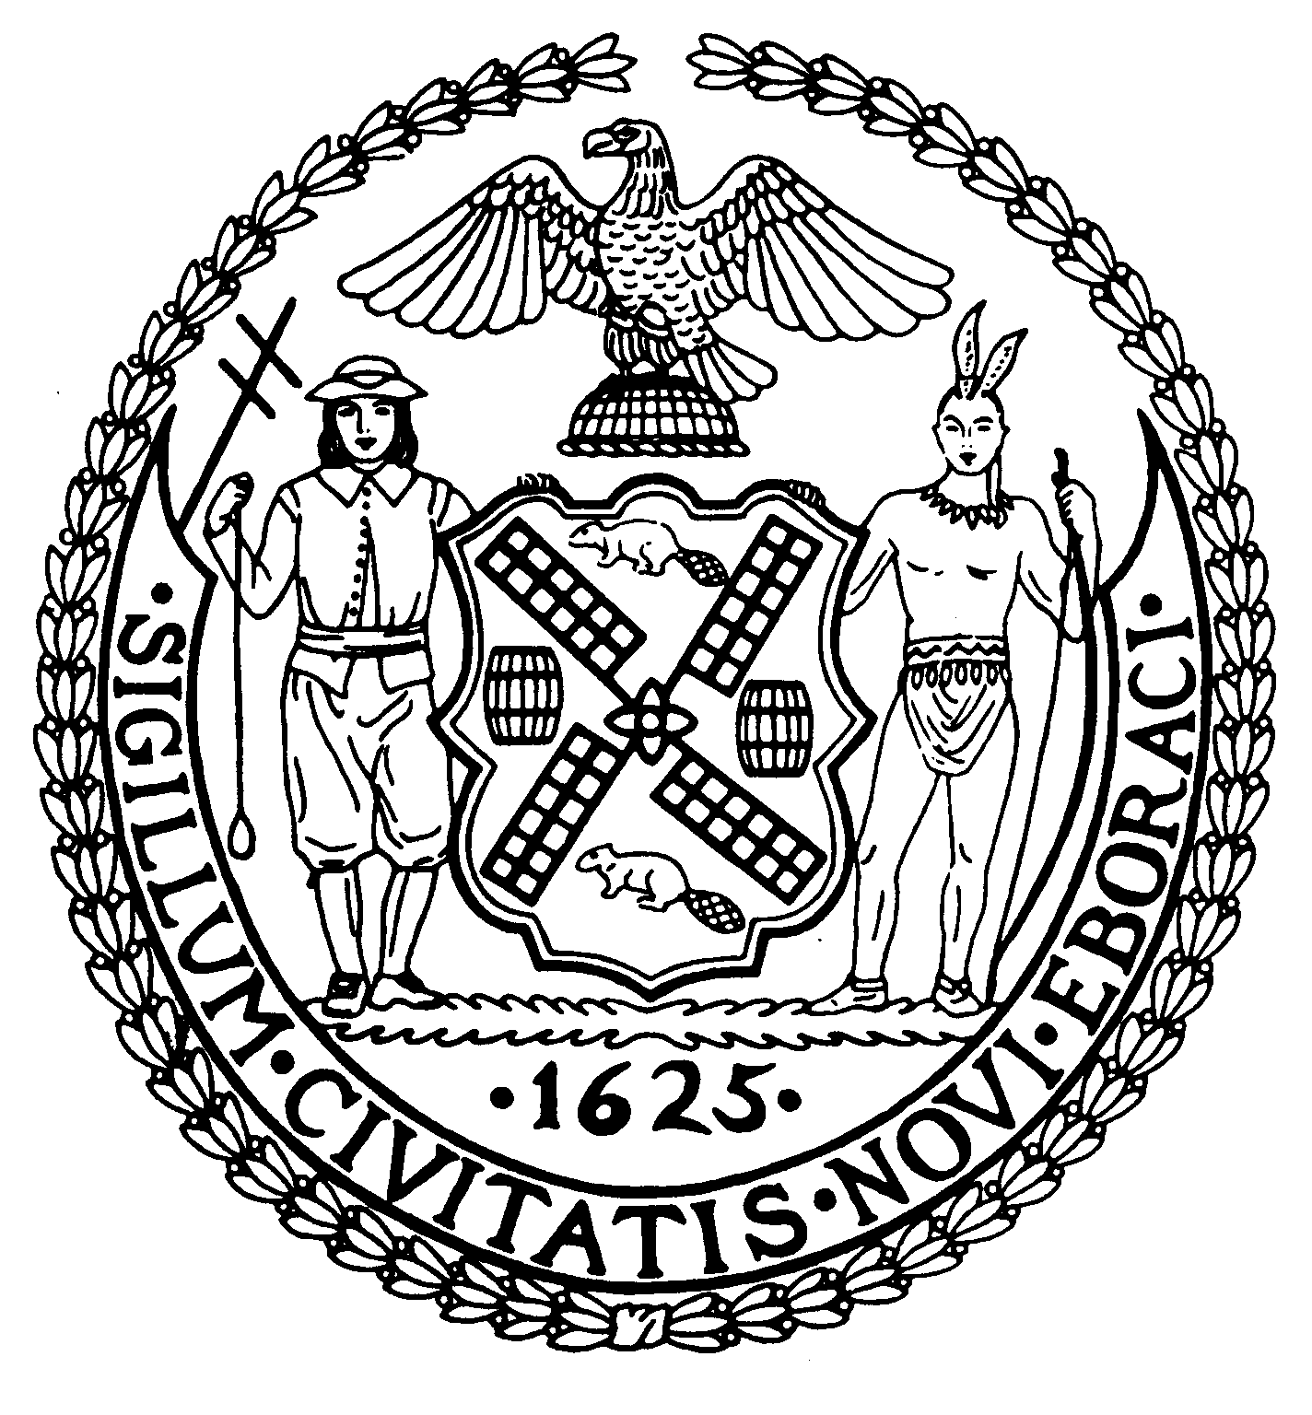
Chair New York, N.Y. 10022-1106
(212) 758-4340
Latha Thompson (212) 758-4616 (Fax)
District Manager www.cb8m.com - Website

info@cb8m.com - E-Mail

The City of New York
Manhattan Community Board 8

Parks Committee Meeting
Thursday, January 7, 2010, 6:30 PM
New York Blood Center, 310 East 67th St.
Conference Room One

CB8 members present: Susan Evans, Rita Popper, Peggy Price, David Rosenstein, Barbara Rudder, Barry Schneider, Judy Schneider, Teri Slater.
Review of the conversion of the Queensboro Oval—that has been used in the summer as a ball field and in winter as a tennis facility—to year-round usage as a tennis center
Peggy Price, co-chair of the Parks Committee, opened the meeting, welcoming the community, as well as Charles Kloth, concessions director for the Park Dept., and Dr. Tony Skonick, manager of the Sutton East Tennis Facility. The committee had two related items to discuss: generally, how to improve communications with the Parks Dept. in order to address issues in a timely manner, and specifically, the status of the Queensboro Oval.
As detailed, the Parks Committee had not learned of an amendment to the lease with the Sutton East Tennis Club—to extend its tennis usage from 8 months to year round—in time for the Community Board to discuss the impact on the community. This amendment eliminates summer usage of the Oval as a ball field.
Postscript. As a direct result of this meeting, Manhattan Parks Commissioner Castro informed the committee the next day that the Parks Dept. would cancel its agreement for year-round use of the Queensboro Oval as a tennis facility. The Oval will again be a ball field during summer months.
During the meeting, Charles Kloth said that Tony Skolnick came to the Parks Dept. last year with his proposal for year-round tennis at the Queensboro Oval. The Parks Dept. found merit with this plan. The clay field, under the Queensboro Bridge, is slippery when wet and generally not very suitable for a ball park. Debris from the bridge falls on the field. As a major user of the Oval, Arlene Virga, Executive Director of the Yorkville Youth Athletic Association, had been consulted. In her view, the field was not good and safe for her little leagues. With the change of Queensboro Oval to full time tennis use, her organization was promised time for ball playing on Randalls Island and court time at the tennis facility for her tennis program.
According to Mr. Skolnick, thousands of tennis players use his facility each year, but only about a couple of hundred people play ball there. The tennis facility will pay the city an additional $175,000, plus a percentage of profits for the extended use per year.
Mr. Kloth said that last April the Parks Dept. notified the Community Board and Borough President that a review of the proposal was in affect. But the Parks Committee never received that notice. Toward late November, the Committee received notification of public hearing on the issue—the first such information it had received on the subject. But that notice came too late for the Committee to schedule a review of the conversion on its December meeting agenda.
Judy Schneider gave a history of the area, which she had previously prepared. In 1988 the Glick Organization applied to the old Board of Estimate to build two 50 some story towers on the piece of property located from 1st to York Avenues between 60 and 61st Streets. Glick was granted a zoning change. Along with the zoning was attached a Restrictive Declaration that spelled out certain mitigation in order to lessen the impact on the community including the improvement of open space in the community. The Glick project was not built. When Milstein (later on Brodsky) applied to develop a portion of the Glick Site, City Planning then sent the matter to the Community Board which passed a resolution that was forwarded to City Planning which established the ground rules for how the mitigation on the balance of the Glick Site was to be carried out by future developers. The specific mitigation for the Milstein/Brodsky Site was to give about 1 million dollars in capital money to restore the Queensboro Oval. In addition, Milstein/Brodsky had to give about $850,000 to a dedicated maintenance fund for this location. The principal would remain and the interest would be use for upkeep.”
The meeting drew a sizable crowd of ball players, many of whom spoke of their long-time use of the Oval. They disagree that the field is not safe to use. They noted that no other ball fields exist in our community board, and the players do not want to go to Randalls Island because of the difficulty getting there. Many were also outraged that they were not informed of the change. Neighbors said they enjoyed watching the games. This is one of the only fields to have lights and bleachers. An email was read from one neighbor who said expressed his love of the field, and also said this field is used for marathon training, bicycle riding, jogging, etc.
Community Board members voiced an array of concerns:
- Opposition to the conversion of public parks spaces to commercial use.
- Concern that the Community Board had not been notified in advance about the change in usage of the Oval.
- Concern over displaced ball players. Committee members asked the Parks Dept. to make certain that, if the ball field was to be eliminated, every displaced ball player has another place nearby to play ball.
- The legality of the current contract.
- Unanswered questions over why the ball field had not been maintained properly and the status of the maintenance fund.
It was suggested that a Chair Jackie Ludorf send a letter to Commissioner Benepe spelling out the Committee’s concerns. In addition, the committee decided to hold a meeting with several members of the Parks Dept. and other involved parties to seek answers the outstanding questions.
Note: The Parks Dept.’s January 8 decision to rescind the amended contract has eliminated CB8M’s need to write to Commissioner Benepe or hold an additional meeting on the Queensboro Oval issue.

2. Ensuring that CB8M Receives Timely Information on Issues Affecting Parks in Our District
The discussion centered on ways to ensure that the CB8M Parks Committee is informed about the city’s plans for our parks in a timely fashion.
Charles Kloth, the Parks Dept.’s concessions director, spelled out the department’s requirements for notifying community boards about planned changes in city parks: 15 days’ advance notice of a public hearing on plans to award a contract for a significant concession in a park, and 40 days’ advance notice on plans for a Request for Proposals.
However, according to CB8M Parks Committee members, such rules fail to meet the needs of our Community Board—as illustrated by the lack of timely information provided the Committee about converting the Queensboro Oval to all-tennis facility. In that case, the CB8M Parks Committee was apprised these plans too late to schedule a meeting about them before the Parks Dept. contracted for year-round tennis-playing at the site.
According to CB8M members, learning about a parks issue via a 15-days’ public hearing notice, with little information on it, effectively limits the Community Board and the public’s opportunity to address an issue. Many working people cannot attend the city’s daytime public hearings. But the community board--which holds evening meetings that are more accessible to the public--needs 4-6 weeks’ lead time to plan a meeting on an issue and notify all stakeholders.
CB8M attendees discussed various ways that we could obtain more timely and thorough information about plans for our parks. To accomplish this goal, it was decided that the Parks Committee co-chairs would regularly contact Mr. Kloth’s office to enquire about any new concession plans concerning parks in our district. Another CB8M member suggested that the Parks Dept. include CB8’s Parks Committee co-chairs on the list of recipients getting emails on “anything that goes out from the Parks Department.” In addition, a CB8M member cited the need for district managers to play a bigger role in getting more timely information from the city.
The Parks Dept.’s Mr. Kloth expressed his willingness to communicate regularly with our Community Board. As he maintained, the Parks Dept. “does dozens of RFPs and other notices and is not trying to slip something by” the public.
Mr. Kloth provided CB8M members at the meeting with a list of 72 current concessions in CB8 district parks, most of which involve food vending in Central Park. He said that the only recent changes to the list were 4 new fruit and vegetable carts in Central Park, selected, he said as “ready-to-eat alternatives to pretzels.”
As an update on previously discussed concessions, Mr. Kloth reported difficulties with plans for having a specialty cart near Central Park’s Bethesda Fountain. But because “everybody likes the idea,” the Parks Dept. is still considering the plan and may issue a new RFP for this concession. He also said that the Parks Dept. would give CB8M “a head’s up” on when it will bring the Community Board design plans for the four Central Park tennis bubbles.

