Jacqueline Ludorf 505 Park Avenue
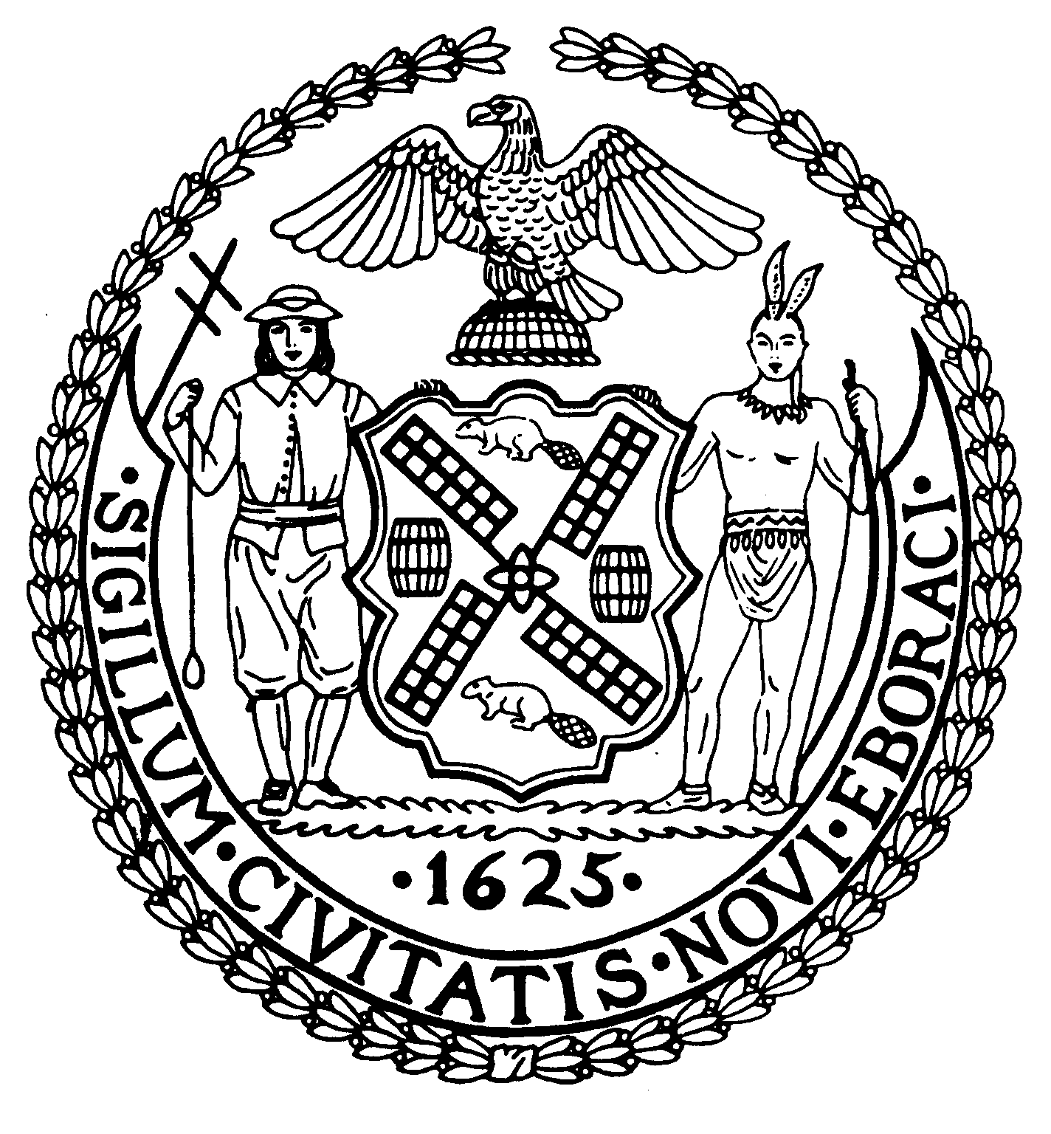
Chair Suite 620
New York, N.Y. 10022

Latha Thompson (212) 758-4340
District Manager (212) 758-4616 (Fax)
info@cb8m.com- E-Mail
www.cb8m.com – Website

The City of New York
Manhattan Community Board 8

Manhattan Community Board 8
Environment and Sanitation Committee Meeting
Tuesday, January 12, 2010
New York Blood Center
310 East 67th Street, Auditorium
6:30 pm

Board Members Present: Dave Kleckner, Debbie Teitelbaum, Roy Carlin,
Jonathan Horn, Mary Pike, Ellen Polivy
Committee Members Absent: None
Number of Attendees: 8

Meeting was called to order at 6:35pm

1. Stephanie Kinlock, Public Affairs Manager, Con Ed, gave an update
regarding the York Substation and Cornell Network.
The York Substation project began 1 1/2 years ago on East 75th Street
and York Avenue. The project is currently on hold due to a slow economy. As Con Ed is forced to re-evaluate major capital projects, the York Substation will not be resumed until 2020 at the earliest. While more energy is needed for buildings that have gone up, there is a slowdown in new construction so the need for a new substation is not at the forefront of priorities. Construction activity along York and First
Avenues is currently being done to tie up loose ends and will be completed by the end of January.

2. The Cornell Network will also not resume until 2020, at the same time as the York Substation.

3. Summer and early Fall projects (gas, steam, and electric) at East
75th Street between York and the FDR have been completed.

4. Safety issues:
Black smoke emitted from the 74th Street steam generator plant. Con Ed
employees notified DEP. Result from DEP is not known. There are still
four to five demineralization trailers parked in front of plant and will remain there until the Internal Water Purification system is complete. They are taking up parking spaces but overall they don't make noise and will be done within two months.

5. Work on the facade of the 74th Street Steam Plant was started in the
Fall. It is ongoing work and they are waiting on permits from the DOB
for the FDR side of the building. Completion timetable depends upon
permits and weather. Temperature needs to be approx. 40-50 degrees. The
project should be completed by the Spring.

6. Infrastructure improvements: none scheduled now. Con Ed is working
with the MTA on the Second Avenue Subway on off-hour shifts.

7. The owner of Felice, a restaurant on 64th and First Avenue, lodged
complaints regarding a clogged grate with a board member. Ms. Kinlock
offered to check into the issue with more information. Debbie Teitelbaum will follow up with the board office to provide information to Ms. Kinlock.

8. Committee member stated that the Con Ed website needs to be updated.
Also questioned whether scaffolding could be removed from the Steam
Plant on sides of building that are completed. Ms. Kinlock did not think so, but will speak with plant manager.

9. Ms. Kinlock unaware of Con Ed's position, if any, regarding hydrofracking.

10. Ms. Kinlock provided follow-up information later in the month in response to questions posed at the meeting, as follows:

1. Does Con Ed’s East 74th Street Steam Plant burn #4 and/or #6 oil for heating?
The facility burns #6 to make steam for the steam system.

2. Regarding the scaffolding present on both sides of the East 74th Street Steam Plant and in front of a neighboring residential building, is it possible to remove the scaffolding where work has already been completed?
Safety regulations require the scaffolding to remain in place until all work is completed. Unfortunately, our crews are unable to partially remove the scaffolding.

3. Please update Con Ed’s website to reflect the most current information about the York substation?
I contacted our Webmaster to request the website be updated to reflect the deferral of the York substation project. Descriptive information about the substation is still present, but a service date is no longer listed.

4. What is Con Ed’s position on hydro fracturing?
New gas supplies will improve service reliability and keep costs low, which is good for New York State’s economy. However, it is very important to be very careful about drilling near the watershed. Even if complying with all regulations, drilling near the watershed is risky. While Con Ed is not necessarily against this process, the location of drilling is of concern to the company.

New/Old Business:
Committee is planning on holding a February meeting to get an update on
the Third Water Tunnel. Meeting may include discussion of conditions at
the Sanitation Dept garage that overlooks the FDR between 73rd and 74th
that was demolished. Reconstruction is on hold due to lack of
capital funding, and members would like to learn of interim and
long-term plans, as well as to discuss current safety, security and
sanitary conditions at the site.

Committee discussed planning an informational forum on air quality
impacts of heating oil and boilers in residential buildings, including
in the context of recent reports citing extremely poor ambient air
quality on the Upper East Side.

Meeting adjourned at 7:50pm.

Respectfully submitted,
Debbie Teitelbaum and David Kleckner
Co-chairs Environment and Sanitation Committee

