Jacqueline Ludorf 505 Park Avenue
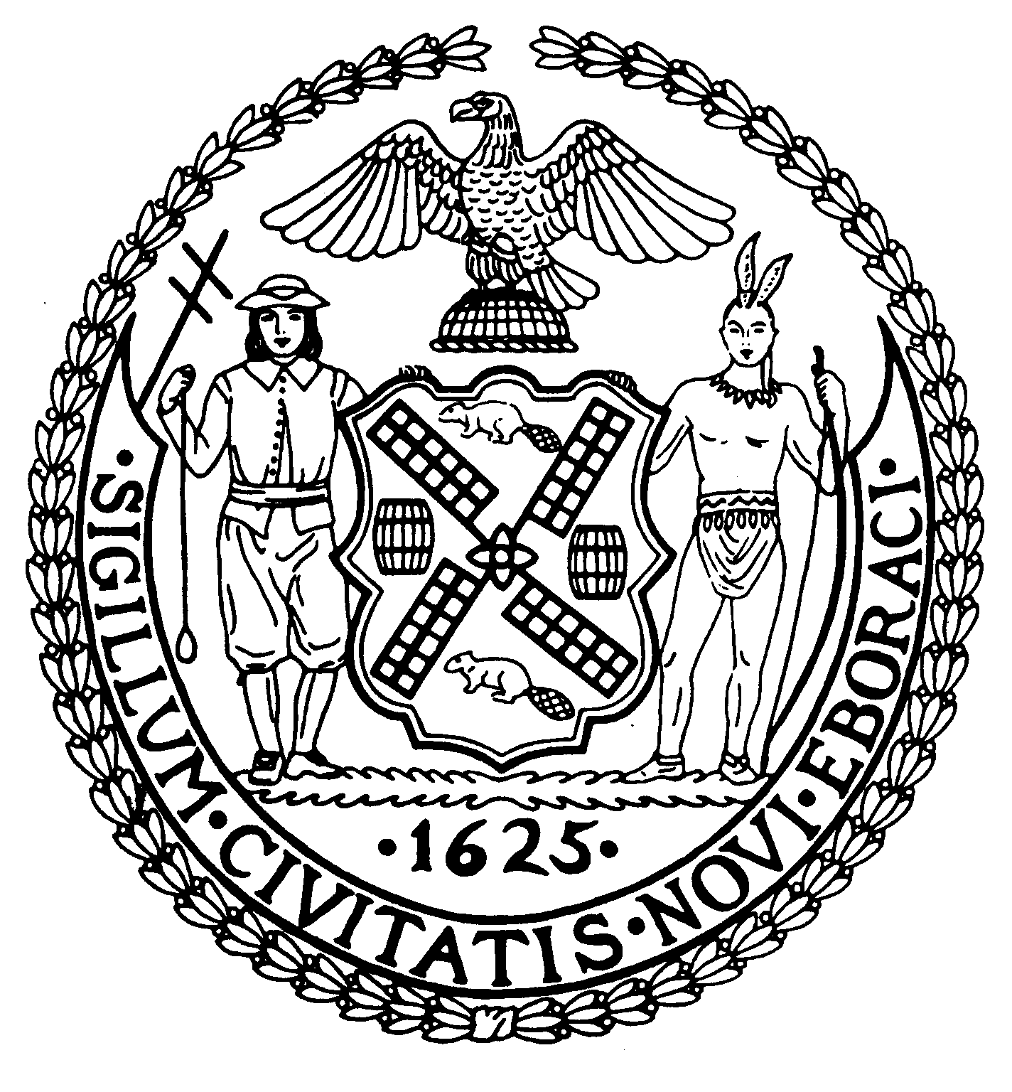
Chair Suite 620
New York, N.Y. 10022

Latha Thompson (212) 758-4340
District Manager (212) 758-4616 (Fax)
www.cb8m.com Website
info@cb8m.com - E-Mail

The City of New York

Manhattan Community Board 8

Transportation Committee Meeting
New York Blood Center
310 East 67th Street, Conference Room 1

Wednesday, January 6, 2010
6:30PM

Agenda

- A construction update on the Roosevelt Island Tram. (This is a joint item with the Roosevelt Island Committee)
- A discussion of the East 67th Street Signage Proposal by Memorial Sloan Kettering.
- A discussion of the bus layover for Bolt Bus Service on Third Avenue and East 61st Street.

- Old Business
- New Business

Jonathan Horn and Charles Warren, Co-Chairs

