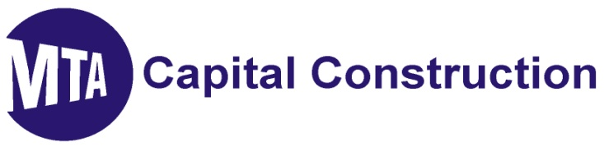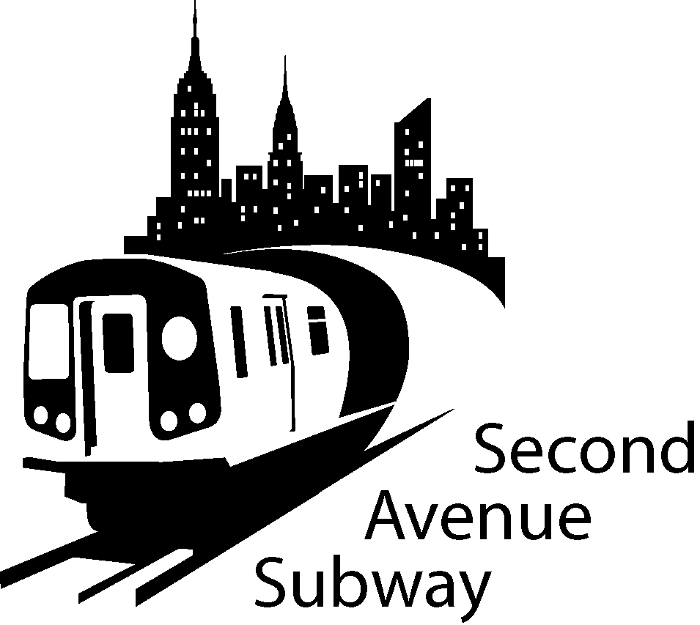

2nd Avenue Subway Construction Look Ahead
FEBRUARY 28ST 2011 to March 14th 2011
location | description of work
100th to 99th Streets | Set up Rebar Fabrication Yard. Con Edison pulling & splicing cables.
99th to 97th Streets | Verizon: Pull cable and splice at 97th St. (7pm-7am). Breakout and relocate existing cables south of 98th. Cap Existing 30” Gas at Metropolitan hospital
97th to 96th Streets | Install secant piles at north/west wall of Ancillary 2. Excavate and Deck for watermain at intersection. Install 36” watermain and backfill when complete
  To... | 2nd ave subway email list
96th to 95th Streets | Excavate and Deck for Water main center of 96th. Excavate and install 16” house connection for 1849 2nd Avenue Excavate and install 35” watermain heading south.
95th to 94th Streets | Installation of cellar ties at 1814 2nd Ave.
94th to 93rd Streets | Interior demolition of Rainbow Hardware (Entrance One)
93rd to 92nd Street | Mucking operations suspended until further notice.
92nd to 91st Streets | Tunnel Boring Machine completed west tunnel. Back up operations to reposition & reassemble TBM for east tunnel run. TBM currently between 65th and 66th Streets
91st to 90th Streets | Continuing ground freezing.
87th to 86th Streets | Maintenance and Protection of Traffic center lanes. Install electric duct banks between manholes. Reconstruct Electric Man Hole Roof SWC E87th St. Support Con Edison in disconnecting and removing section of existing 30” gas main.
86th to 85th Streets | Maintenance and Protection of Traffic - Contractor material storage area Install and tie in new 12” water main
85th to 84th Streets | Maintenance and Protection of Traffic - Contractor material storage area Support Con Edison in disconnecting and removing section of existing 30” gas main
84th to 83rd Streets | West Side: Continue support of excavation installation. Mechanical excavation of rock. DOT permit for closure of 83rd St between 1st & 2nd and between 2nd & 3rd Aves between 9am and 5pm Monday thru Friday. Continue with electric conduit & Man Hole installations. Con Ed cable/splicing
83rd to 82nd Streets | West Side: Excavate for the replacement of Con Edison electric service box and duct bank 83rd Street (1st to 2nd Ave). Continue with electric conduit & Man Hole installations. Con Ed cable/splicing
79th to 78th Streets | Maintenance and Protection of Traffic
74th to 73rd Streets | Installation of dewatering tanks.
73rd to 72nd Streets | Continuing controlled blasting activities on 2nd Ave.
72nd Street North West Side | Reducing sidewalk to 9 feet. Setting protection barrier and creating work zone. Continuing interior demolition of 259 E 72nd St Ancillary 1. Gas and electrical utility relocation
72nd to 71st Streets | Contractor storage area
71st to 70th Streets | Installation of double height employee work trailers
70th to 69th Street | Continuing of controlled blasting activities. Installation of instrumentation to 63rd Street
69th Street North West Side | Gas and electrical utility relocations

SAS WORK HOURS:
MONDAY - FRIDAY, 7:00 AM TO 10:00 PM
SATURDAY, 10:00 AM TO 7:00 PM

BE ADVISED: Con Ed, Empire City Subway and Verizon may be performing cable and gas line work outside regular SAS construction Hours. If you have additional questions, please contact Claudia Wilson at (212) 792-9716 from 9:00AM to 5:00PM Monday through Friday, or contact the 2nd Avenue Subway Hotline 24 hours/7 days a week at (646)252-2670.

TRAFFIC UPDATES
100th to 95th Streets
- Four lanes of traffic on the East side of Second Avenue
- Work zone will be set up on the West side of Second Ave
- The West side work zone will be approximately 40 Foot wide, plus 7 Foot sidewalk
- No Standing at Anytime on the West side of Second Ave 95th Street to 101st Street
- No Standing on the East side 7AM-10AM and 4PM-7PM Monday-Friday
- No Standing on East side 10AM-4PM, EXCEPT Trucks Loading and Unloading

95th Street to 91St Streets
- Four lanes of traffic currently on WEST Side of 2nd Avenue
- Work zone is set up on the EAST SIDE of 2nd Avenue
- The EAST SIDE work zone will be approximately 40 FOOT wide, plus 7' sidewalk
- No Standing at anytime on the EAST SIDE of Second Ave 91st Street to 96th Street
- No Standing on the WEST SIDE 7AM-10AM and 4PM-7PM Monday-Friday except truck loading or unloading
- Parking ALLOWED on WEST SIDE 7PM-7AM Weekdays and all day Saturday

87th to 82nd Streets
- From 88th Street to 86th Street Traffic lanes East and West of Center Work Zone
- From 85th Street to 82nd Street Three lanes of traffic on the East Side of Second Ave
- Work zone will be set up on the West Side of Second Ave South of 85th St
- The West Side work zone will be approximately 40 Foot wide, plus 7 Foot sidewalk
- No Standing at Anytime on the East Side of Second Ave 87th Street to 82nd Street
- No Standing at Anytime on the West Side of Second Avenue 87th to 86th Street, EXCEPT Trucks Loading and Unloading
- No Standing on East or West Side 85th to 82nd Streets (NYPD Traffic enforced)

74th to 68th Streets
- Work zone is set up on the EAST SIDE of Second Ave
- The EAST SIDE work zone will be approximately 40 FOOT wide, plus 7’sidewalk
- No Standing at anytime on the EAST SIDE of Second Ave
- No Standing on the WEST SIDE 7AM-10AM and 4PM-7PM Monday-Friday
- No Standing on WEST SIDE 10 AM-4PM, EXCEPT trucks loading and unloading
- Parking ALLOWED on WEST SIDE 7PM-7AM Weekdays and all day Saturday & Sunday

