

Tuesday, April 19, 2011

Take The Bike Smart Pledge!
DOT is gearing up for its highly-anticipated Don’t Be a Jerk public service campaign, which asks all New Yorkers to ride responsibly. Over the past four years DOT has made a commitment to cyclists, adding over 250 new miles of bike lanes, better bike lane designs and thousands of new bike racks. Now we’re asking cyclists to make a commitment to respectful riding.  Want to stand up for civil cycling? Take the Bike Smart Pledge and share it with fellow riders. Keep New York's streets pleasant for everyone – including other cyclists! – by yielding to peds, riding with traffic and staying off the sidewalk.  Tweeting about cycling? Show your commitment to civil riding using the hashtag #dbaj. | 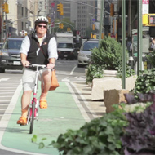

Get ready to ride - May is Bike Month!  Ready to ride? Check the Bike Month website or the DOT events page for hundreds of great events, rides and deals! Feeling artistic? Check out DOT’s Art By Bike tour, a guided ride through the city to see unexpected art in all sorts of places. Have your kids outgrown their bikes? Come to a Bike Bonanza featuring kids bike swaps, learn-to-ride classes, and free helmets brought to you by DOT, Recycle-A-Bicycle, Bike New York and NYPD. Check the online calendar or go to your local bike shop for a poster listing more events, rides, classes and deals! | 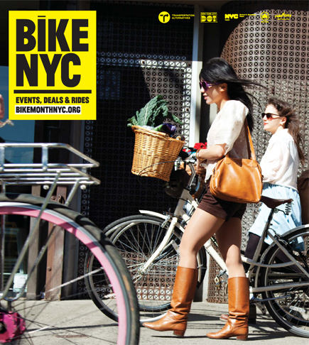

Hot off the Press, the 2011 Cycling Map is new and improved!
Just in time for spring, the 2011 Cycling Map is here! In addition to featuring 50 new miles of bike lanes, including parking protect paths on First and Second Avenues in Manhattan, the new map includes a host of handy new features to simplify and improve your ride. Stop by your local bike shop to pick up your map, or request one via 311. Map posters also available starting in May.
- Never quite sure what the difference is between the green, red and orange lines on the map? Look no further than the new 2011 Cycling Map Legend, with photos to show what kind of streets to expect and help you plan your ride.
- Not sure how long it will take to get from Astoria to Greenpoint? The new Travel Time estimator on the scale bar is there to help you out.
- Flat tire? Looking for a bike shop? The new grey and white gear icon attaches a number to every bike shop on the map; check the list on the Brooklyn/Queens side of the map for the name, phone number and address.
- Not sure where bicycle access is on the George Washington Bridge? Confused by the Queensboro? Updated bridge diagrams show you exactly how to get to and from your favorite bridges, and include clear information on street directions, staircases and places where you need to walk your bike.
- Wondering about the rules of the road? Check the map for info on New York City’s major cycling rules. Want more? Go to www.nyc.gov/bikesmart for cycling information and tips in English, Spanish, Chinese, Russian, Italian, Korean and Haitian Creole.

Road and Bridge Closures
For information about street closures, sign up for weekly traffic advisories.

Free Helmets
The DOT has distributed over 23,000 official NYC Bicycle Helmets for free to New York City residents. You can schedule a time to get fitted for an NYC helmet at one of the DOT's Safety Cities by calling 311. Check our events calendar for upcoming fittings.

Suggest Bike Rack Locations
DOT is working with community boards to identify strategic areas to install clusters of new bike parking. If you'd like to suggest an area that needs bike parking, contact your community board.

Report a Problem or Send Kudos
Potholes
Street Construction Hazards
Missing or Broken Street Signs
Report a faded or damaged bike lane: Call 311
Other Complaints and Compliments
Share NYCycles

We sent you this issue of NYCycles because you signed up for bicycle updates from DOT.
Forward to a friend
view email in browser
Unsubscribe thompson@cb8m.com
New York City Department of Transportation
55 Water Street, 9th Floor
New York, NY 10041
Add us to your address book

