Jacqueline Ludorf 505 Park Avenue, Suite 620
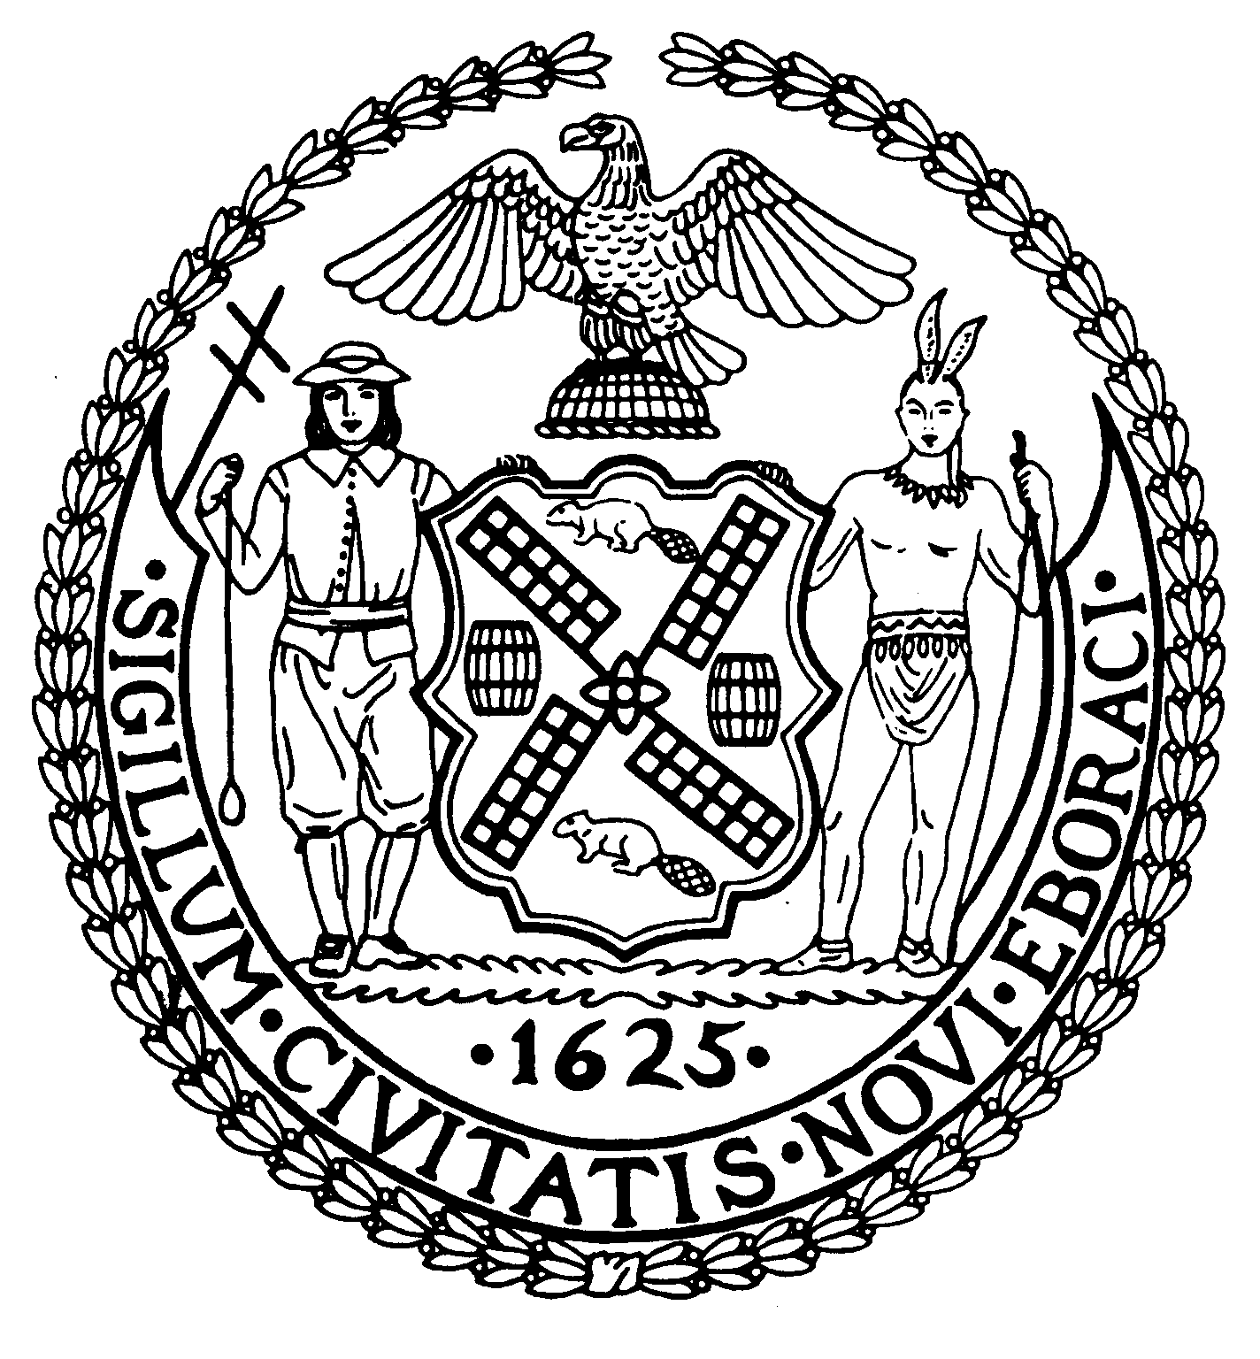
Chair New York, N.Y. 10022-1106

(212) 758-4340
(212) 758-4616 (Fax)
Latha Thompson
District Manager www.cb8m.com - Website
info@cb8m.com - E-Mail

The City of New York
Manhattan Community Board 8

THIS IS AN OFFICIAL GOVERNMENT NOTICE
PLEASE DO NOT REMOVE UNTIL 6/07/11

Public Forum

MARINE TRANSFER STATION
FOR
DUMPING GARBAGE AT E. 91ST STREET

- THE CITY’S PROPOSED PLANS
AND THE FIGHT TO STOP IT-

Invited Guests:

- NYC Dept of Sanitation
- Local Elected Officials
- Gracie Point Community Council

Monday, June 6, 2011
Stanley Isaacs Neighborhood Center
Dining Room
415 E. 93rd Street
6:30PM

