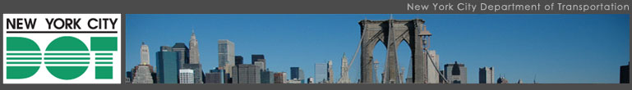
This spring 2011, the New York City Department of Transportation is partnering again with the Mayor’s Community Affairs Unit & New York Cares to paint selected barrier sites around the City. Individual artists or artist teams are invited to submit applications. DOT will help oversee artwork production, translation and design implementation. DOT and NY Cares will provide materials and tools to paint the design. Barrier sites will be primed and prepped in advance by NYC Community Cleanup. Each selected artist shall be assigned a site within one of the five boroughs and will be responsible for translating the design and overseeing the painting of the design onto the barriers. NY Cares volunteers will be assigned to assist each artist at a site on one Saturday in early spring 2011 to paint the design. To participate in this initiative, submit your application by Friday, February 25, 2011. Selected designs will be posted on the website and artists will be notified by phone within two weeks if selected. Visit www.nyc.gov/urbanart to download the application. Also, we strongly suggest that you visit www.flickr.com/photos/nycstreets/collections to view examples of completed projects to gain an understanding of the types of designs that have been approved by the Advisory Committee in the past.

Josh Orzeck
Community Coordinator
Manhattan Borough Commissioner's Office
NYC Dept. of Transportation
59 Maiden Lane, 37th Floor
New York, NY 10038

(212) 839-6218
(212) 839-6285 (fax)
****************************************************************************************************
This message and any attachments are solely for the individual(s) named above and others who have been specifically authorized to receive such and may contain information which is confidential, privileged or exempt from disclosure under applicable law. If you are not the intended recipient, any disclosure, copying, use or distribution of the information included in this message and any attachments is strictly prohibited. If you have received this communication in error, please notify us by reply e-mail and immediately and permanently delete this message and any attachments.
Thank you.
NYC – Department of Transportation
****************************************************************************************************

