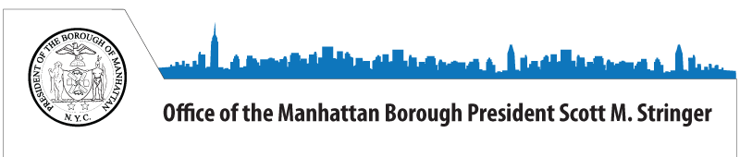
Updated - Back 2 School Basics: A Guide for Parents in English, Spanish & Chinese
Dear Parent,
The school year begins tomorrow, and my office, in partnership with Make the Road New York and New York Immigration Coalition, is committed to ensuring your child starts the new school year off right. This quick-reference guide to New York public schools, also available in Spanish and Chinese, provides a wealth of resources at your fingertips to make the transition as smooth as possible. You will find phone numbers and websites of relevant agencies and organizations, as well as sections on registration, free meals, free transportation, special needs and English Language Learner services, and many other topics. You will also find out how to get more involved in your child’s education and in improving our City’s schools. I encourage you to carefully review the guide and share it with other parents that may find it useful.
Read more about the Back 2 School Basics guide in the New York Daily News.
Have a great school year and don't hesitate to contact us with any questions or concerns.
Sincerely,
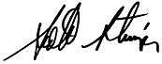
Scott M. Stringer,
Manhattan Borough President

