Important Notice

E. 78th Street Pedestrian Bridge
HBMC029R

Closure - Northbound FDR Drive
between E. 77th Street and E. 79th Street
to install electrical for new lights

Monday, August 22, 2011 from 11:00 p.m. until Tuesday, August 23 at 5:00 a.m.
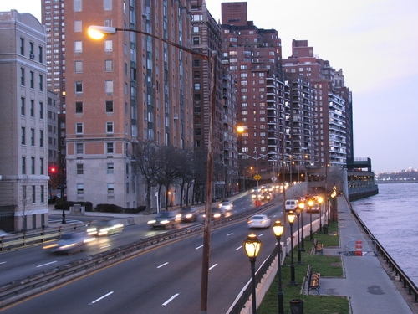
As part of the reconstruction project for the E.78th Street Pedestrian Bridge, there will be a closure of the eastern most lane of the northbound FDR Drive between E. 77th Street and E. 79th Street on Monday, August 22 between 11:00 p.m. and 5:00 a.m. on Tuesday, August 23.

The main span of the bridge was removed on July 31; the new span is expected to be placed by crane on September 25. Electrical work is being performed in advance of the new bridge span being placed.

Community Liaison Deborah Howes is available to provide information about the project at
347-834-7455 or via email at E78thStreetPedestrianBridge@gmail.com.

For all NYC non-emergency services, including inquiries regarding NYCDOT Construction projects, dial 311. Be prepared to give the following information so your call can be directed properly: your name and the borough; the project number – HBMC029R, and a return phone number.
