
NEW YORK CITY DEPARTMENT OF HEALTH AND
MENTAL HYGIENE
Thomas Farley, MD, MPH
Commissioner
FOR IMMEDIATE RELEASE
Friday, August 19, 2011
(347) 396-4177

Health Department to Spray Pesticide to Reduce Adult Mosquito Populations

First human case of West Nile Virus confirmed; Spraying scheduled for parts of Queens
to help prevent West Nile Virus

August 19, 2011 - To reduce mosquito activity and the risk of West Nile virus, the Health Department will spray pesticide from trucks in parts of Queens on Tuesday, August 23 between the hours of 8 p.m. and 6 a.m. the following morning, weather permitting. In case of bad weather, application will be delayed until Wednesday, August 24, during the same hours.

The Health Department confirmed the season’s first human case of West Nile virus in a 64-year-old Manhattan woman. West Nile virus is transmitted to humans via mosquito bite. It is unclear where she was exposed to mosquitos carrying the virus; she had recently travelled within and also outside of New York City. She became ill and was hospitalized in early August. She developed an infection and is now recovering in the hospital.

Mosquitoes carrying West Nile virus continue to be found in four NYC boroughs (Queens, Staten Island, Brooklyn and the Bronx), and with the first human case now identified, all New Yorkers are reminded to protect themselves against mosquito bites. Recent heavy rain may have had a short-term effect of reducing mosquito populations, but has also created much more standing water around the city in which mosquitoes can breed. Building owners and residents are urged to look for and eliminate standing water.

The Health Department urges all New Yorkers to take steps to prevent West Nile viral infection. New Yorkers age 50 and older should be especially careful as they are more likely to become seriously ill if infected.
Reducing Exposure to Mosquitoes
- Use an approved insect repellent containing DEET, picaridin, oil of lemon eucalyptus (not for children under three), or products that contain the active ingredient IR3535. Repellents with greater than 10% DEET should not be used on children. Other tips on insect repellents can be found on the Health Department website: http://www.nyc.gov/html/doh/html/wnv/wnvfaq4.shtml
- Make sure windows have screens, and repair or replace screens that have tears or holes.
- Eliminate any standing water from your property, and dispose of containers that can collect water. Standing water is a violation of the New York City Health Code.
- Make sure roof gutters are clean and draining properly.
- Clean and chlorinate swimming pools, outdoor saunas and hot tubs. Keep them empty or covered if not in use; drain water that collects in pool covers.
Report standing water by calling 311 or visiting nyc.gov/health/wnv.

Locations of Application
Borough | Includes parts or all of these Neighborhoods | Boundaries | Includes parts or all of these Zip Codes
Queens | Auburndale, Briarwood, Flushing, Kew Gardens, Kew Gardens Hills, Queensboro Hill Pomonok | Bordered by 150th Street, Grand Central Parkway, Main Street, Long Island Expressway, and Utopia Parkway to the East; 43rd Avenue, Cherry Avenue, Kissena Boulevard, Maple Avenue, College Point Boulevard and Long Island Expressway to the North; Grand Central Parkway, Union Turnpike and Park Lane to the West; and Metropolitan Avenue and Hillside Avenue to the South | 11355,11365 11358, 11367  11415, 11418  11435
For these sprayings, the Health Department will use a very low concentration of Anvil®, 10 + 10 a synthetic pesticide. When properly used, this product poses no significant risks to human health, but the Health Department recommends that people take the following precautions to minimize direct exposure:

- Whenever possible, stay indoors during spraying. People with asthma or other respiratory conditions are encouraged to stay inside during spraying since direct exposure could worsen these conditions.
- Air conditioners may remain on, however, if you wish to reduce the possibility of indoor exposure to pesticides, set the air conditioner vent to the closed position, or choose the re-circulate function.
- Remove children’s toys, outdoor equipment, and clothes from outdoor areas during spraying. If outdoor equipment and toys are exposed to pesticides, wash them with soap and water before using again.
- Wash skin and clothing exposed to pesticides with soap and water. Always wash your produce thoroughly with water before cooking or eating.
The use of pesticides in New York City is conducted in accordance with labeling approved by the Environmental Protection Agency (EPA) and the New York State Department of Environmental Conservation (DEC). For further information, visit http://www.nyc.gov/html/doh/html/wnv/wnvfaq21.shtml.

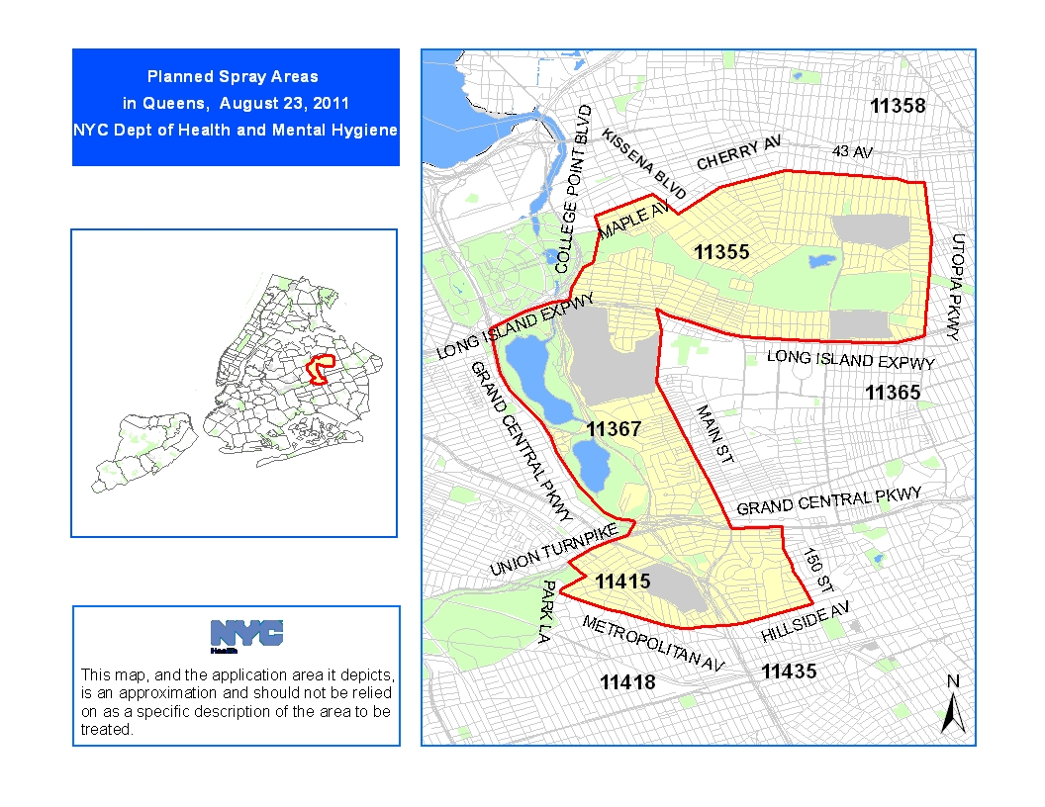

###

#WNV007-11

MEDIA CONTACT: (347) 396-4177
Susan Craig/Chanel Caraway: pressoffice@health.nyc.gov

