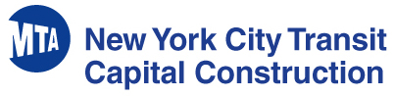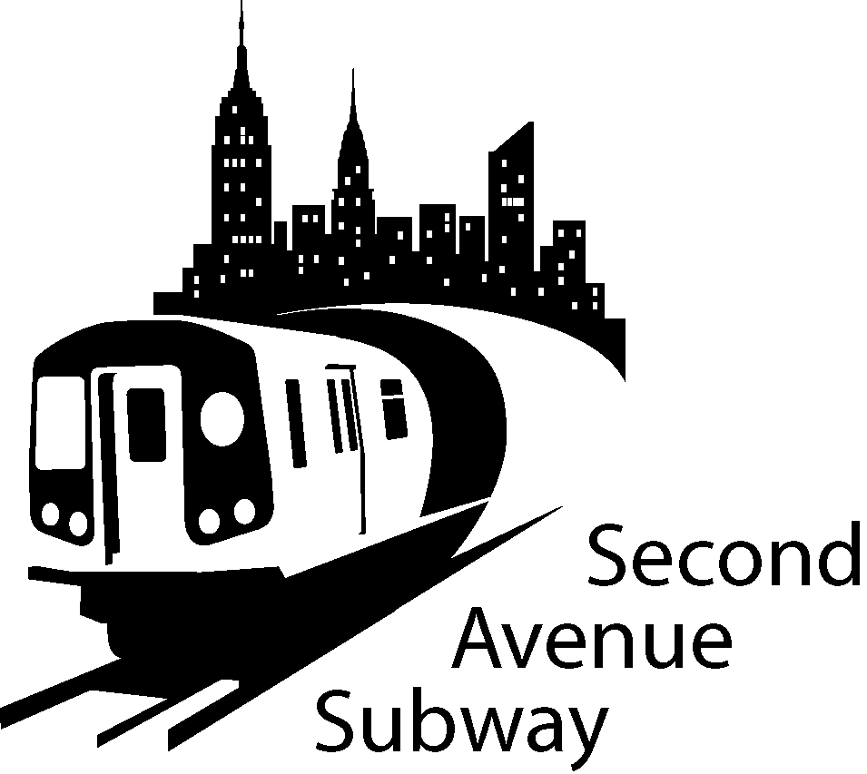

Second Avenue Subway Project:
86th Street Station
Notice of Extended Work Hours

83RD Street between 1st and 2nd Avenues:
In order to complete necessary Verizon work at 83rd Street, Verizon crews will be working 24 hours shifts beginning on Friday June 17th, and continuing until Friday June 24th. This work will require 83rd Street between 1st and 2nd Avenues to be closed. The street will be open at 1st Avenue for local traffic and deliveries, but there will be no through traffic to 2nd Avenue.

