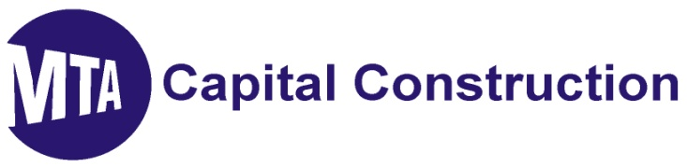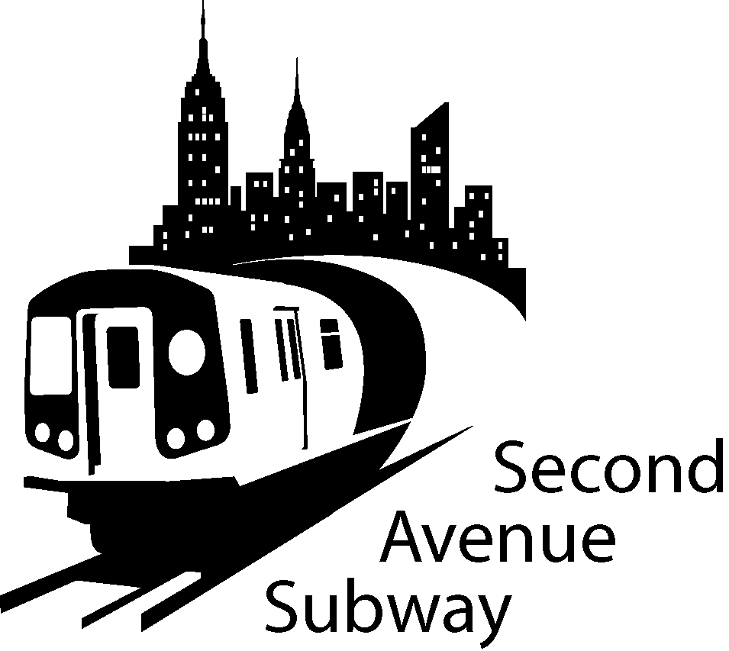

2nd Avenue Subway Construction Look Ahead
May 24th 2011 to June 13th 2011
location | description of work
100th to 99th Streets | Crane assembly and fabrication yard preparation for Slurry Wall construction underway.
99th to 97th Streets | Continuing installation of secant piles for Ancillary #2. Verizon work pulling cable 7pm to 7am
97th to 96th Streets | Construction of sewer chamber. South lane traffic closure in effect at 97th Street. Con Edison pulling & splicing cables.
  To... | 2nd ave subway email list
96th to 95th Streets | South lane traffic closure in effect at 96th Street. Con Edison pulling & splicing cables. Begin excavation of guide walls for Entrance # 3. (Rite Aid Plaza) Removal of existing timber piles.
95th to 94th Streets | Traffic transition zone
94th to 93rd Streets | East Side: Beginning excavation for support of foundation of Ancillary # 1 (93rd St). West Side: Begin interior demolition inside Entrance # 1 (Rainbow Hardware)
93rd to 92nd Street | Continuing with rock removal from Launch Box. Operation of vertical conveyor.
92nd to 91st Streets | Tunnel Boring Machine excavating East Tunnel. TBM currently on 2nd Avenue between 84th and 83rd Streets  Streets
91st to 90th Streets | Repaving of work zone
88th to 87th Streets | Maintenance and Protection of Traffic Contractor material storage area
87th to 86th Streets | Excavate to locate utilities. Pre drill rock to prepare for excavation of North Shaft
86th to 85th Streets | Maintenance and Protection of Traffic Contractor material storage area
85th to 84th Streets | Maintenance and Protection of Traffic Contractor material storage area
84th to 83rd Streets | Pre drill rock to prepare for excavation of South Shaft
83rd to 82nd Streets | Maintenance and Protection of Traffic Contractor material storage area.
79th to 78th Streets | Activating center lane work site for concrete deliveries to TBM tunnel. Intermittent controlled blasting in tunnel.
74th to 73rd Streets | Operation of water treatment plant.
73rd to 72nd Streets | Controlled blasting activities resume on 72nd St. shaft area. Operational testing of spoils conveyance rack system. Continuing construction of work zone enclosure building.  .
72nd Street North West Side | Continuing interior abatement and preparation for dismantling of 259 E 72nd St. Removing fire escapes. Gas and electrical utility relocation. Con Edison utility tie in. Support of Excavation work on the West Side.
72nd to 71st Streets | Con Edison connection of generator to main grid. Contractor storage and maintenance area.
71st to 70th Streets | Con Edison connection of generator to main grid. Contractor offices and storage area.
70th to 69th Street | Continuing of controlled blasting activities on 2nd Avenue. Demobilization of work site in preparation of construction work zone enclosure building. Scheduled overnight work for dismantling of 885 Crane June 2nd 3rd 4th
69th Street North West side | Gas and electrical utility relocations. Preparation for asbestos abatement of 235 E 69th Street.
69th to 68th Street West side | Begin underground controlled blasting to excavate cross passage way.
63rd Street South West side | Removal of 7 trees 1 tree to be transplanted
63rd Street North West side | Begin dismantling of plaza area, establishing work zone. Temporary Maintenance and Protection of Traffic for test pit activity.
3rd Ave. between 63rd and 64th Street | Installation of Maintenance and protection of traffic on east side of 3rd Avenue. No parking permitted traffic reduced to 5 lanes

SAS WORK HOURS:
MONDAY - FRIDAY, 7:00 AM TO 10:00 PM
SATURDAY, 10:00 AM TO 7:00 PM
WORK UNDER DECKING PERMITTED 24 HOURS

BE ADVISED: Con Ed, Empire City Subway and Verizon may be performing cable and gas line work outside regular SAS construction Hours. If you have additional questions, please contact Claudia Wilson at (212) 792-9716 from 9:00AM to 5:00PM Monday through Friday, or contact the 2nd Avenue Subway Hotline 24 hours/7 days a week at (646)252-2670.

TRAFFIC UPDATES
100th to 95th Streets
- Three lanes of traffic on the East side of Second Avenue
- Work zone will be set up on the West side of Second Ave
- The West side work zone will be approximately 40 Foot wide, plus 7 Foot sidewalk
- No Standing at Anytime on the West side of Second Ave 95th Street to 101st Street
- No Standing on the East side 7AM-10AM and 4PM-7PM Monday-Friday
- No Standing on East side 10AM-4PM, EXCEPT Trucks Loading and Unloading

95th Street to 91St Streets
- Four lanes of traffic currently on WEST Side of 2nd Avenue
- Work zone is set up on the EAST SIDE of 2nd Avenue
- The EAST SIDE work zone will be approximately 40 FOOT wide, plus 7' sidewalk
- No Standing at anytime on the EAST SIDE of Second Ave 91st Street to 96th Street
- No Standing on the WEST SIDE 7AM-10AM and 4PM-7PM Monday-Friday except truck loading or unloading
- Parking ALLOWED on WEST SIDE 7PM-7AM Weekdays and all day Saturday

87th to 82nd Streets
- From 88th Street to 85th Street Traffic Four lanes of traffic West of East Work Zone starting April 27, 2011.
- From 85th Street to 82nd Street Four lanes of traffic West of East Work Zone Second Ave starting approx. beginning of May 2011.
- No Standing at Anytime on the West Side of Second Ave 88th Street to 87nd Street
- No Standing on the WEST SIDE between 82nd to 87th Street 7AM-10AM and 4PM-7PM Monday-Friday except truck loading or unloading(NYPD Traffic enforced)

74th to 68th Streets
- Work zone is set up on the EAST SIDE of Second Ave
- The EAST SIDE work zone will be approximately 40 FOOT wide, plus 7’sidewalk
- No Standing at anytime on the EAST SIDE of Second Ave
- No Standing on the WEST SIDE 7AM-10AM and 4PM-7PM Monday-Friday
- No Standing on WEST SIDE 10 AM-4PM, EXCEPT trucks loading and unloading
- Parking ALLOWED on WEST SIDE 7PM-7AM Weekdays and all day Saturday & Sunday

