Jacqueline Ludorf 505 Park Avenue
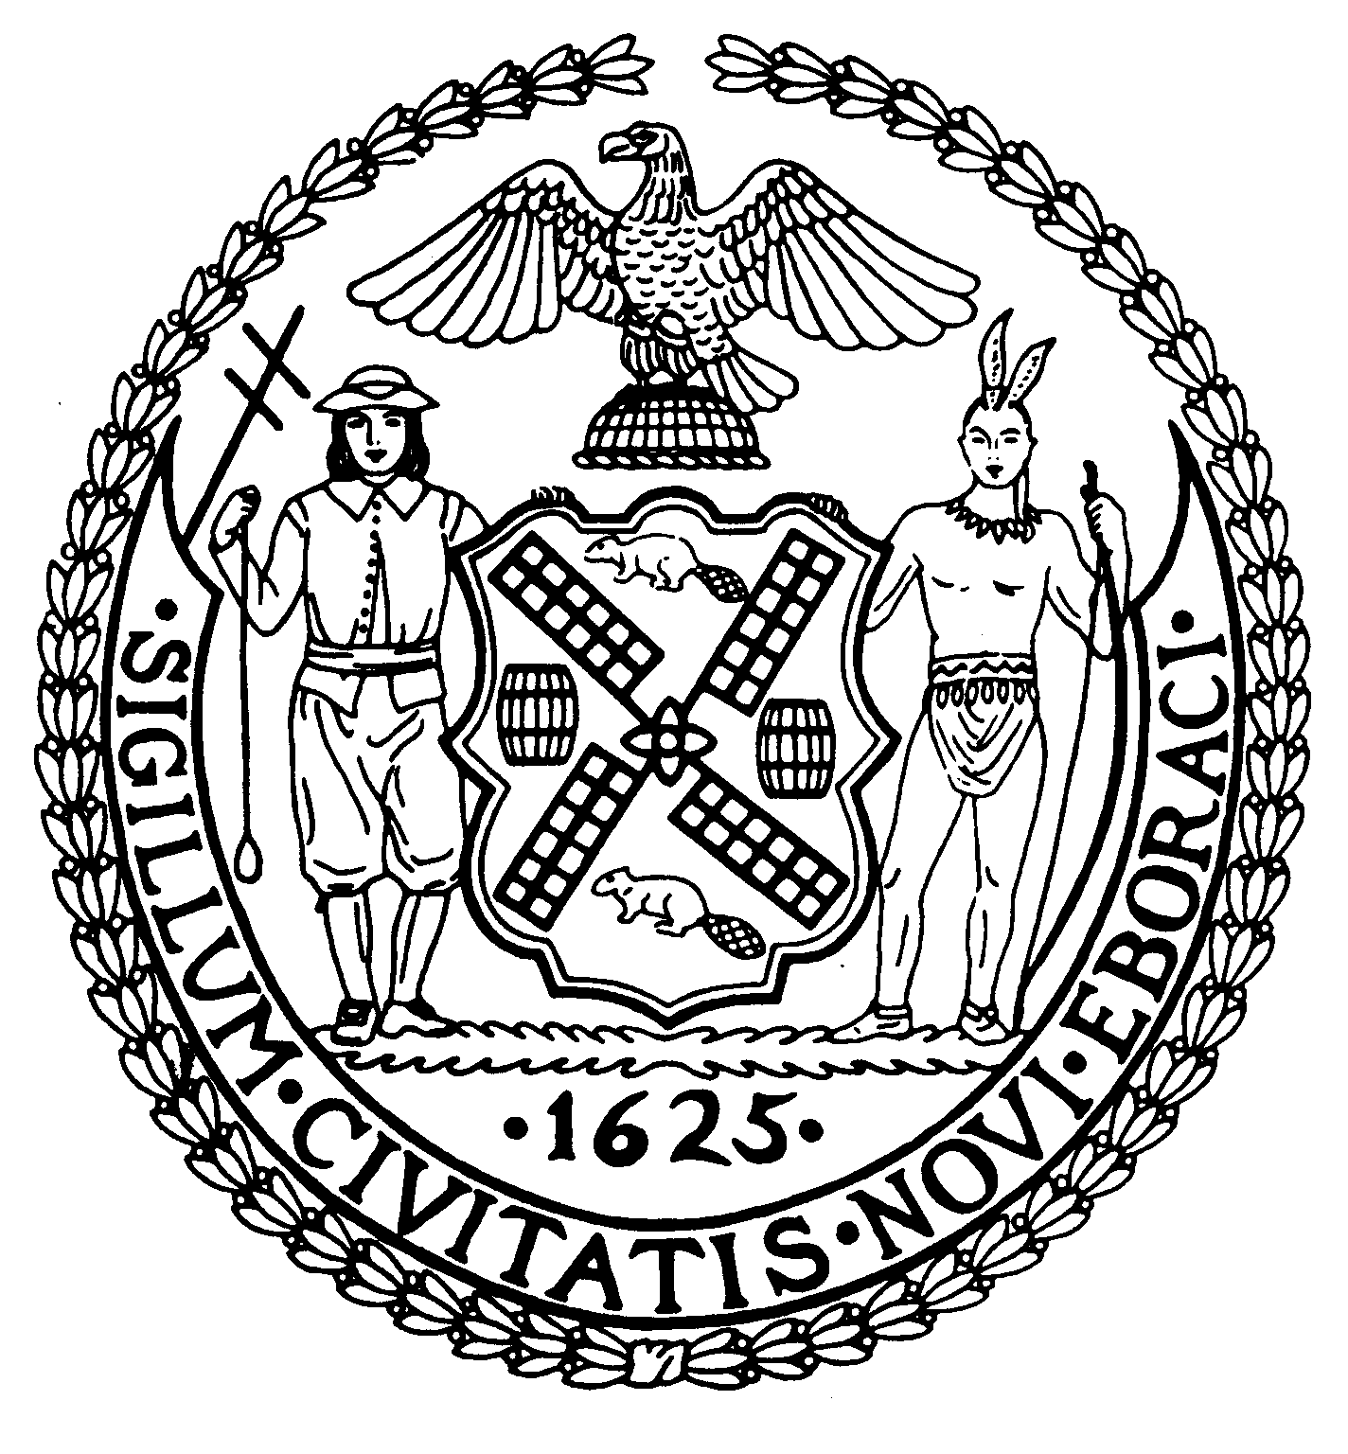
Chair Suite 620
New York, N.Y. 10022

Latha Thompson (212) 758-4340
District Manager (212) 758-4616 (Fax) info@cb8m.com - E-Mail www.cb8m.com – Website

The City of New York
Manhattan Community Board 8

Date: Sunday, May 22nd, 2011
Location: Citywide - http://www.nyc.gov/html/dca/html/news/shred_fest_nyc.shtml

The Department of Consumer Affairs and the Mayor’s Office of the Criminal Justice Coordinator, in partnership with Department of Parks & Recreation and the Department of Sanitation, will be conducting the City’s Fourth Annual Shred Fest, a free paper-shredding event to increase public awareness of identity theft prevention, will be held Sunday, May 22 from 10 a.m. to 4 p.m. New Yorkers can shred personal documents at multiple locations throughout the five boroughs. Please visit the DCA website for more information.

