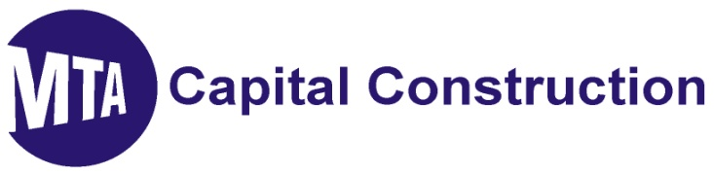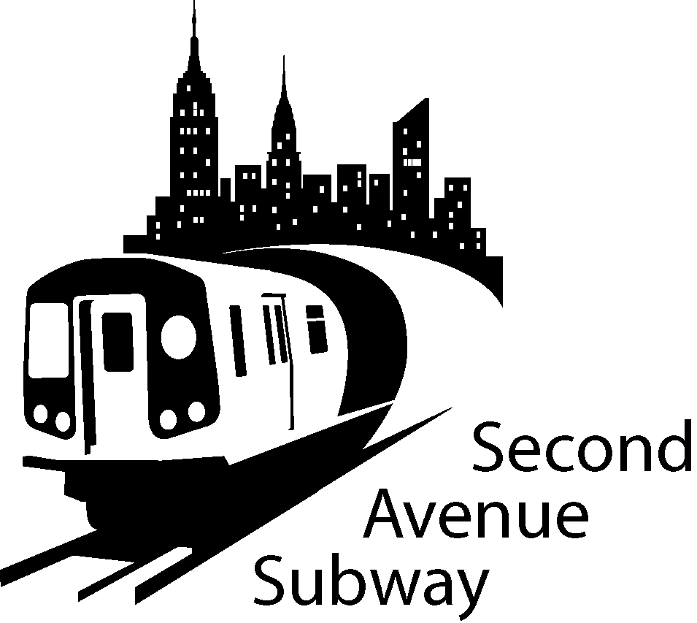

2nd Avenue Subway Construction Look Ahead
–January 11th 2011 to January 31^{ST 2011}
location | description of work
100th to 99th Streets | West Side: Excavate and install support of excavation for sewer relocation and 12” gas tie in
99th to 97th Streets | West Side; Excavate and install 8” gas tie in. Excavate and cap existing 12” and 24” gas.
97th to 96th Streets | West Side: Begin establishing new contractor storage zone. Excavate and install support of excavation for new 12” gas. Work zone shift to South side of 96th St for water main work.
  To... | 2nd ave subway email list
96th to 95th Streets | West Side: Begin demobilizing contractor storage zone. Excavate and install support of excavation for 48”sewer main. Excavate for 8” gas tie in.
95th to 94th Streets | Storage of TBM excavated material under decking
94th to 93rd Streets | Removal and storage of TBM excavated material under decking.  Interior demolition of Rainbow Hardware (Entrance One)
93rd to 92nd Street | Operation of vertical conveyor system. Removal of TBM excavated material. Trucking operations 7AM to 10PM
92nd to 91st Streets | Tunnel Boring continuing south – tunnel heading currently between 68th and 69th Streets.
91st to 90th Streets | Initiating ground freezing
87th to 86th Streets | West Side: Excavation and install new Con Edison manhole. Convert existing Con Edison vault into manhole. Excavate and install support of excavation for North shaft  Center Work Zone: Excavate and install 16” sewer and manhole. Extending center work zone for additional sewer line replacement. Excavate for 30”gas main installation.
86th to 85th Streets | Maintenance and Protection of Traffic - Contractor material storage area
85th to 84th Streets | Maintenance and Protection of Traffic - Contractor material storage area
84th to 83rd Streets | West Side: Complete new Con Edison electric manhole. Excavate and install support of excavation for South Shaft. Install concrete electric service boxes. Stabilize wall at Gothic Cabinet Install new sewer line for 83rd west of 2nd Ave – Excavate & install 8” sewer connection to Gothic Cabinet
83rd to 82nd Streets | East Side: Excavate for the replacement of Con Edison electric service box and duct bank (1st to 2nd Ave) Continue with duct installation.
79th to 78th Streets | Maintenance and Protection of Traffic
74th to 73rd Streets | Establish water treatment plant
73rd to 72nd Streets | Mobilize equipment. Installation of sidewalk sheds. Removal protection and transplanting of trees on the North and South side of 72nd Street. Prepare for start of controlled blasting
72nd to 71st Streets | Reducing sidewalk South West side of 72nd St Stripe traffic lanes for traffic switch Removal and transplanting of trees. Create work zone on North West side of 72nd St. for Con Edison utility relocation.
71st to 70th Streets | Removal and transplanting of trees. Reducing sidewalk to 9 feet. Installation of 8 job trailers
70th to 69th Street | Installation of sidewalk sheds. Removal, protection and transplanting of trees on North and South sides of 69th Street. Prepare for start of controlled blasting.

SAS WORK HOURS:
MONDAY - FRIDAY, 7:00 AM TO 10:00 PM
SATURDAY, 10:00 AM TO 7:00 PM

BE ADVISED: Con Ed, Empire City Subway and Verizon may be performing cable and gas line work outside regular SAS construction Hours. If you have additional questions, please contact Claudia Wilson at (212) 792-9716 from 9:00AM to 5:00PM Monday through Friday, or contact the 2nd Avenue Subway Hotline 24 hours/7 days a week at (646)252-2670.

TRAFFIC UPDATES
100th to 95th Streets
On January 15th 97th Street will be closed between 2nd and 3rd Ave during the hours of 12am and 6am for crane assembly
- Four lanes of traffic on the East side of Second Avenue
- Work zone will be set up on the West side of Second Ave
- The West side work zone will be approximately 40 Foot wide, plus 7 Foot sidewalk
- No Standing at Anytime on the West side of Second Ave 95th Street to 101st Street
- No Standing on the East side 7AM-10AM and 4PM-7PM Monday-Friday
- No Standing on East side 10AM-4PM, EXCEPT Trucks Loading and Unloading

95th Street to 91St Streets
- Four lanes of traffic currently on WEST Side of 2nd Avenue
- Work zone is set up on the EAST SIDE of 2nd Avenue
- The EAST SIDE work zone will be approximately 40 FOOT wide, plus 7' sidewalk
- No Standing at anytime on the EAST SIDE of Second Ave 91st Street to 96th Street
- No Standing on the WEST SIDE 7AM-10AM and 4PM-7PM Monday-Friday except truck loading or unloading
- Parking ALLOWED on WEST SIDE 7PM-7AM Weekdays and all day Saturday

87th to 82nd Streets
- From 88th Street to 86th Street Traffic lanes East and West of Center Work Zone
- From 85th Street to 82nd Street Three lanes of traffic on the East Side of Second Ave
- Work zone will be set up on the West Side of Second Ave South of 85th St
- The West Side work zone will be approximately 40 Foot wide, plus 7 Foot sidewalk
- No Standing at Anytime on the East Side of Second Ave 87th Street to 82nd Street
- No Standing at Anytime on the West Side of Second Avenue 87th to 86th Street, EXCEPT Trucks Loading and Unloading
- No Standing on East or West Side 85th to 82nd Streets (NYPD Traffic enforced)

74th to 68th Streets
- Work zone is set up on the EAST SIDE of Second Ave
- The EAST SIDE work zone will be approximately 40 FOOT wide, plus 7’sidewalk
- No Standing at anytime on the EAST SIDE of Second Ave
- No Standing on the WEST SIDE 7AM-10AM and 4PM-7PM Monday-Friday
- No Standing on WEST SIDE 10 AM-4PM, EXCEPT trucks loading and unloading
- Parking ALLOWED on WEST SIDE 7PM-7AM Weekdays and all day Saturday & Sunday

