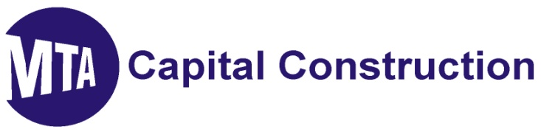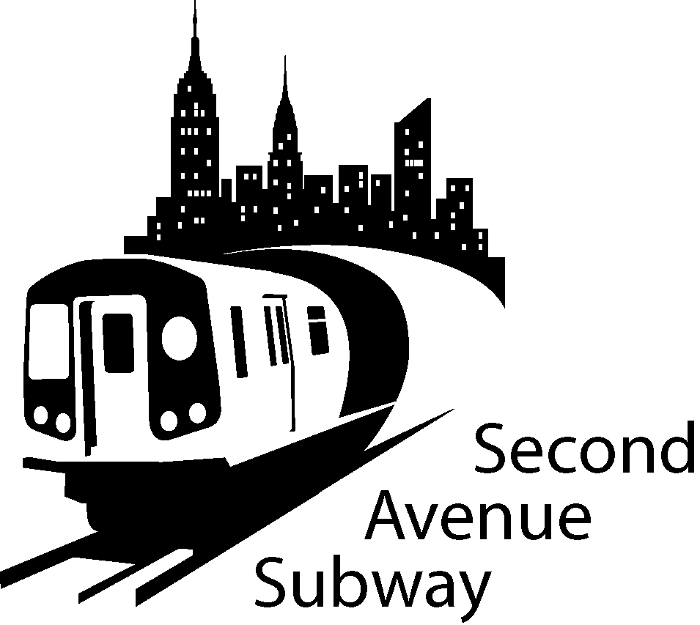

2nd Avenue Subway Construction Look Ahead
December 21^{ST –} January 11th 2011
location | description of work
100th to 99th Streets | Excavate and install new Con Edison duct bank
99th to 97th Streets | West Side: Installation of 42” sewer, and manholes. Breakout and relocate existing ECS and Con Ed cables
97th to 96th Streets | West Side: Continuing Jet Grouting at north foundation of 1873 2nd Avenue and removal of timber piles. This work may require extended work hours. Excavate and install Con Edison manholes and ducts, 12” gas crossing and service, 12” water mains & ECS ducts. Excavate and install 36-IWatermain. “Mobilize for Secant Pile installation @ Ancillary #2.” (Century Lumber)
  To... | 2nd ave subway email list
96th to 95th Streets | West Side: Excavate and install crossing and Con Edison ducts.  Traffic switch to North Side of 96th Street
95th to 94th Streets | Installation of cellar ties at 1814 2nd Ave. Installing tunnel dewatering system under decking.
94th to 93rd Streets | Removal and storage of TBM excavated material under decking.  EECruz-Tully JV: Interior demolition of Rainbow Hardware (Entrance One)
93rd to 92nd Street | Operation of vertical conveyor system. Removal of TBM excavated material. Trucking operations 7AM to 10PM
92nd to 91st Streets | Tunnel Boring continuing south – tunnel heading currently between 71st and 70th Streets.
91st to 90th Streets | Continuing preparations for ground freezing
87th to 86th Streets | West Side: Begin excavation for new Con Edison manhole. Convert existing Con Edison vault into manhole  Center Work Zone: Reconstruct existing Con Edison electric manhole. Excavate and set pre cast electric manhole. Excavate for existing sewer replacement extending center work zone for additional sewer line replacement Excavate for 30”gas main installation
86th to 85th Streets | Maintenance and Protection of Traffic - Contractor material storage area
85th to 84th Streets | Maintenance and Protection of Traffic - Contractor material storage area
84th to 83rd Streets | West Side: Installation of new 12” gas main. It is necessary to intermittently close 83rd St. between 2nd and 3rd Ave in order to complete the utility work. Install Support of Excavation piles and advance drilling for rock removal. Excavate and support existing ECS duct back
83rd to 82nd Streets | West Side: Excavate for the replacement of Con Edison electric service box and duct bank 83rd Street (1st to 2nd Ave) Continue with duct installation.
79th to 78th Streets | Maintenance and Protection of Traffic
73rd to 72nd Streets | Installation of Geotechnical Ground Instrumentation. Mobilize equipment. Installation of sidewalk sheds. Relocation of M 72 bus stop to the EAST Side of 2nd Ave. on 72nd St. Removal protection and transplanting of trees on the North and South side of 72nd Street. Prepare for start of blasting
72nd to 71st Streets | Reducing sidewalk South West side of 72nd St Stripe traffic lanes for traffic switch Removal and transplanting of trees. Relocation of East bound M 72 bus to East side of 2nd Avenue Installation of generators
71st to 70th Streets | Establish work zone. Adjust Maintenance and Protection of Traffic lay out. Installation of building instrumentation. Performing test pits. Removal and transplanting of trees. Installation of trailers
70th to 69th Street | Installation of Geotechnical Ground Instrumentation. Mobilize equipment. Installation of sidewalk sheds. Removal, protection and transplanting of trees on North and South sides of 69th Street. Prepare for start of blasting

SAS WORK HOURS:
MONDAY - FRIDAY, 7:00 AM TO 10:00 PM
SATURDAY, 10:00 AM TO 7:00 PM

BE ADVISED: Con Ed, Empire City Subway and Verizon may be performing cable and gas line work outside regular SAS construction Hours. If you have additional questions, please contact Claudia Wilson at (212) 792-9716 from 9:00AM to 5:00PM Monday through Friday, or contact the 2nd Avenue Subway Hotline 24 hours/7 days a week at (646)252-2670.

TRAFFIC UPDATES
100th to 95th Streets
- Four lanes of traffic on the East side of Second Avenue
- Work zone will be set up on the West side of Second Ave
- The West side work zone will be approximately 40 Foot wide, plus 7 Foot sidewalk
- No Standing at Anytime on the West side of Second Ave 95th Street to 101st Street
- No Standing on the East side 7AM-10AM and 4PM-7PM Monday-Friday
- No Standing on East side 10AM-4PM, EXCEPT Trucks Loading and Unloading

95th Street to 91St Streets
- Four lanes of traffic currently on WEST Side of 2nd Avenue
- Work zone is set up on the EAST SIDE of 2nd Avenue
- The EAST SIDE work zone will be approximately 40 FOOT wide, plus 7' sidewalk
- No Standing at anytime on the EAST SIDE of Second Ave 91st Street to 96th Street
- No Standing on the WEST SIDE 7AM-10AM and 4PM-7PM Monday-Friday except truck loading or unloading
- Parking ALLOWED on WEST SIDE 7PM-7AM Weekdays and all day Saturday

87th to 82nd Streets
- From 88th Street to 86th Street Traffic lanes East and West of Center Work Zone
- From 85th Street to 82nd Street Three lanes of traffic on the East Side of Second Ave
- Work zone will be set up on the West Side of Second Ave South of 85th St
- The West Side work zone will be approximately 40 Foot wide, plus 7 Foot sidewalk
- No Standing at Anytime on the East Side of Second Ave 87th Street to 82nd Street
- No Standing at Anytime on the West Side of Second Avenue 87th to 86th Street, EXCEPT Trucks Loading and Unloading
- No Standing on East or West Side 85th to 82nd Streets (NYPD Traffic enforced)

74th to 68th Streets
- Work zone is set up on the EAST SIDE of Second Ave
- The EAST SIDE work zone will be approximately 40 FOOT wide, plus 7’sidewalk
- No Standing at anytime on the EAST SIDE of Second Ave
- No Standing on the WEST SIDE 7AM-10AM and 4PM-7PM Monday-Friday
- No Standing on WEST SIDE 10 AM-4PM, EXCEPT trucks loading and unloading
- Parking ALLOWED on WEST SIDE 7PM-7AM Weekdays and all day Saturday & Sunday

