
Wednesday, July 20, 2011

Bike to the Beach
What better way to cool down after a nice, long bike ride than a dip in the ocean? This summer, try riding your bike to one of the many beaches New York has to offer.  Fort Tilden, Queens: Accessible from Brooklyn via the Shore ParkwayGreenway and Flatbush Avenue or from Queens via Rockaway Beachand the Jacob Riis Boardwalk. If you don’t want to ride all the way, bring your bike on the A train and ride the rest of the way!  Coney Island, Brooklyn: A summer classic, you can easily reachConey Island by riding down NYC’s oldest bike path, Ocean Parkway(built in 1894!). Imagine heading to the Cyclone the same way people did when it opened in 1927! Or take the scenic route along the Shore Parkway Greenway and enjoy the view from under the VerrazannoBridge.  Midland Beach, Staten Island: If you’re headed from the ferry, takeBay Street south towards Gateway Park. Once there, take the greenway down. If you’re headed from inland, take Midland Avenuestraight to the beach.  Orchard Beach, Bronx: The Pelham Parkway and Hutchinson Greenways will lead you towards the Bronx’s manmade marvel. After swimming, head to City Island for some lunch.  Don’t forget, you can always bring a bike on the LIRR and explore beaches farther out. Make sure to purchase a permit and always board the easternmost end of the train car. If you’re headed out to Long Island, use the front-most entrance. | 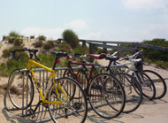

Extension of Bike Path on First & Second Avenues  On July 5, the extension of the First Ave parking-protected bike path began installation. The parking-protected bike path on First Avenue will extend from 34th Street to 49th Street. The path will continue to protect cyclists and shorten crossing distances for pedestrians, enhancing safety for everyone who uses the street. DOT is also installing shared lane markings on First Avenue from 49th to 57th Streets and on Second Avenue from 59th to 34th Street.  All of the improvements in this project have been tailored to specific conditions along the corridor. The first section installed in 2010 has already resulted in a dramatic drop in injuries to all street users onFirst Avenue between Houston and 34th Streets, while increasing cycling volumes. | 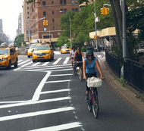  First Avenue bike path already in use

Manhattan Bridge Bike Detour
Until January 2012, the pedestrian and bike paths on the Manhattan Bridge will switch. Cyclists will use the south path, walkers the north side. The detour is a necessary part of the current construction work on the Bridge, which is replacing the 628 suspenders and all of the Bridge's lighting.
During the detour, cyclists will need to walk their bikes up and down the stairway on the Brooklyn side - there's a rail to make it easier. On the Manhattan side, make sure to approach from the south on Bowery.
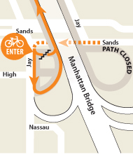 | 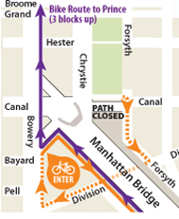
Detour route on the Brooklyn side | Detour route on the Manhattan side

Did You Know?
Bicycle facilities, such as dedicated bicycle lanes and shared lane markings, are an effective and low-cost method of traffic calming. While congestion is caused by too many vehicles in too little space, traffic calming slows down speeding vehicles along streets and increases safety not only for motor vehicle occupants but also cyclists and pedestrians. In a recent DOT study, streets with bicycle facilities were found to have 40% less deadly pedestrian crashes than streets without facilities. Consider some white lines and markings on the ground one of the most efficient ways to create a livable street, especially when compared to costly traffic signals and asphalt speed humps.

Bike Smart!
You need all your senses clear when you ride. Leave the headphones off when you're on your bike. You’ll be able to react more quickly and hear other cyclists and pedestrians on the road. Legally, you can wear one ear bud while riding, but smart cyclists enjoy their mono records at home and keep both ears open for a stereophonic experience of the road.

Road and Bridge Closures
For information about street closures, sign up for weekly traffic advisories.

Free Helmets
The DOT has distributed over 23,000 official NYC Bicycle Helmets for free to New York City residents. You can schedule a time to get fitted for an NYC helmet at one of the DOT's Safety Cities by calling 311. Check our events calendar for upcoming fittings.

Suggest Bike Rack Locations
DOT is working with community boards to identify strategic areas to install clusters of new bike parking. If you'd like to suggest an area that needs bike parking, contact your community board.

Report a Problem or Send Kudos
Potholes
Street Construction Hazards
Missing or Broken Street Signs
Report a faded or damaged bike lane: Call 311
Other Complaints and Compliments

